__________________________________________________

Local Skills Improvement Plan (SEMLEP region)

__________________________________________________

Produced by Northamptonshire and Milton Keynes Chamber of Commerce in partnership with Bedfordshire Chamber of Commerce

MAY 2023

‘This Local Skills Improvement Plan has been approved by the Secretary of State in line with the approval criteria set out in the statutory guidance.’

Contents of report

Introduction pages 3-4

Part 1 pages 5-18
- What are we trying to achieve and why the LSIP matters
- The current skills landscape (jobs, provision, economy) and why changes are needed
- How the LSIP can help drive change, who needs to be involved and what success will look like

Part 2 pages 19-25
- The key outcomes employers want
- Specific skills and training requirements employers need, identifying current provision and where new provision is needed
- Resulting priority changes in local provision required

Part 3 pages 25-32
- What needs to happen to bring about change
- Actions proposed to take forward priorities
- Expected process for effecting delivery, reviewing progress and realising expected benefits

Annexes
Index
- Annex A – LSIP Employer Consultation
- Annex B – Draft Priorities and Roadmap
- Annex C –Power BI (responses)
- Annex D - Methodology
- Annex E – Reports
- Annex F – External Referencing
- Annex G – Top 60 Occupations
- Annex H – Provision needed

Introduction
If we are to make UK Plc more productive we have to address the skills gap that is holding us back economically. The UK Government is currently on a path to reshape the technical skills system to better support the needs of the local labour market and the wider economy. This new system will be driven by employers, colleges and other providers continuing to work together to identify the skills needs of an area, and to begin the process of transforming the delivery of technical education so that it both meets and drives demand for skills locally.
The recent Skills for Jobs White Paper (web-link below) aims to strengthen links between employers and further education providers, placing employers at the heart of defining local skills needs and explore a new role for business representative organisations working with local colleges and employers. The courses offered by providers will be tailored to meet the skill needs of businesses.
https://assets.publishing.service.gov.uk/government/uploads/system/uploads/attachment_data/file/957810/Skills_for_jobs_lifelong_learning_for_opportunity_and_growth__print_version_.pdf
We have many examples of good practice and collaborative working between employers and providers in our region, and there are many things that “work” when we talk about skills, skills provision and business but we simply do not have enough people in the “right” jobs, we do not have enough skilled technicians, engineers, analysts or health and social care professionals - and we certainly do not have enough businesses engaging with the Post-16 Further Education Sector.
There are many reasons for these issues, and to address the skills challenge we face in our region, we are highlighting the need to enhance the education and training system, promote digital skills, foster a culture of lifelong learning, support sector-specific skills development, ensure inclusivity, and addressing our regional and local disparities. By working in conjunction with providers and employers to address the evolving needs of the job market and embed a system of real change we hope to support enhanced productivity, competitiveness, and individual career prospects while driving sustainable economic growth and international competitiveness for businesses within our region.
A key element of this change is the Local Skills Improvement Plan (LSIP) lead by an Employer Representative Body (ERB).

THE EMPLOYER REPRESENTATIVE BODY
Northants and Milton Keynes Chamber of Commerce is the designated Employer Representative Body (ERB) for the South East Midlands area comprising Bedford, Central Bedfordshire, Luton, Milton Keynes, North Northamptonshire and West Northamptonshire. Our role is to lead the development and subsequent reviews of the LSIP working with employers, providers, and local stakeholders.

The South East Midlands ERB will:
- Plan the work to develop and review the LSIP
- Engage with employers, providers, and other stakeholders
- Convene providers and employers so that they have meaningful discussions which lead to the identification and prioritisation of skills needs together with the development of actionable solutions
- Work with a wide range of stakeholders to develop learner demand and employer engagement to support providers, employers, and the wider skills system
- Produce the LSIP report and submit to the Department of Education for approval and publication by the Secretary of State
- Support the delivery of the LSIP and keep the plan under review to ensure it remains relevant to the area’s needs; and
- Where relevant, work with neighbouring LSIP areas on sectors and issues of interest.
- Continue to support delivery of the LSIP priorities with stakeholders

THE SOUTH EAST MIDLANDS ECONOMY AND LABOUR MARKET
- The South East Midlands is a rapidly growing and innovative economy. Benefiting from the central location and connections to international routes together with close proximity to Oxford, London, Cambridge and Birmingham.

- The area includes the fastest growing city economy in Milton Keynes (Source: Centre for Economics and Business Research (CEBR) together with the large towns of Bedford, Luton and Northampton, interspersed with smaller towns and rural areas.

- The South East Midlands is a high growth economy. GVA was reported as £49m in 2020, up from c.£35bn in 2010. The number of enterprises grew by 6% from 2018 to 2022 and employment 2% for the same period. For the period 2015 to 2018, the number of enterprises had increased by 15% and employment 4%. In Luton business start-ups were ranked 3/63 in the whole country and digital connectivity was ranked 1/63 with connections subscribed in excess of 30Mbps

PART 1
What are we trying to achieve?
Local Skills Improvement Plans (LSIPs) were introduced in the Skills for Jobs White Paper in January 2021. The Skills for Jobs White Paper set out an ambitious plan to put employers more firmly at the heart of the skills system to help ensure businesses and people have the skills they need to thrive and progress. The statutory guidance from the Department of Education in October 2022 states that LSIPs should:
- Set out the key priorities and changes needed in a local area to make post16 technical education or training more responsive and closely aligned to local labour market needs.
- Taking into account our regions priority sectors (as highlighted by LEP data pages 13-14), provide a representative and coherent employer view of the skills most needed to support local economic growth and boost productivity and improve employability and progression for learners.
- Set out actionable priorities to better meet these skills needs that employers, providers and stakeholders in a local area can get behind to drive change in ways that add value to relevant local strategies and effectively join-up with other parts of the local skills system.
- Not attempt to cover the entirety of provision within an area but focus on the key changes and priorities that can gain traction and maximise impact informed by robust underpinning evidence, meaningful dialogue between employers and providers and constructive engagement with Local Enterprise Partnerships, Local Authorities and other stakeholders.
- Be drawn up for a period of three years and be reviewed and updated as appropriate during this time to ensure it remains relevant and reflects the skills needs of the specified area.
- Describe how skills, capabilities and expertise required in relation to jobs that directly contribute to or indirectly support Net Zero targets, adaptation to Climate Change or meet other environmental goals have been considered.

Whilst developing the plan we engaged with a range of Stakeholders including Employers, Providers, Trade Bodies, other Employer Representative Bodies and Local Authorities and have considered the results of a range of feedback channels and stakeholder consultations. Whilst there are still stakeholders in our region we wish to engage with in order to gather their views and understand their skills challenges, these are the following areas we will be considering and exploring within the current LSIP roadmap implementation:

- Establish partnerships with educational institutions, training providers, and employers to create a collaborative ecosystem for skill development. Encourage joint initiatives, sharing of resources, and coordination between stakeholders to maximize impact.
- Alongside our regions priority sectors, identify sectors with high growth potential and significant skills gaps, such as digital technology, healthcare, green industries, and construction. Tailor skill development programmes to address the specific needs of these sectors.
- Promote apprenticeships as a valuable pathway for skill development. Encourage employers to offer apprenticeship schemes and work with training providers to expand apprenticeship opportunities across various industries
- Support local colleges and independent training providers in delivering high-quality vocational education and training programmes. Ensure these programmes are aligned with industry standards and offer work-relevant skills that meet employer demands
- Regularly assess the impact of the skills improvement plan by monitoring indicators. Use this data to evaluate the effectiveness of the priorities
- Stay updated on government funding schemes, grants, and initiatives that support local skills development. Seek funding to supplement resources and enhance the reach and quality of skill development programmes.
- Ensure that the local skills improvement plan prioritises equality, diversity, and inclusion. Create opportunities for underrepresented groups, including women, ethnic minorities, and individuals with disabilities, to access and benefit from skill development programmes.

The LSIP focuses on occupations where employers are experiencing difficulties in filling positions. During the research and consultation, many of the occupation shortages, especially for SMEs, were transferable, cutting across many industry sectors. To evaluate provision available and identify gaps, the occupations have been categorised by Occupational Groups and aligned with Occupational Routes and Pathways.

Why the LSIP matters
Employment
Employment numbers in the South East Midlands have (in the main) recovered from the impact of the pandemic to the same level as 2019 at 865,200 with the employment rate for aged +16 is 63.0% rising again, above the national average of 61.1%, but below the peak in 2020 of 64.6% (source: ONS, Annual Population Survey).
Employment by sector within the South East Midlands 2021 is shown below shows:
- The top 80% of employment is included within Logistics & Supply Chain (14%), Business Administration & Support (12%), Retail (12%), Health & Care (11%), Manufacturing (9%), Education (9%), Construction (8%) and Hospitality (6%).
- The largest employment sector is logistics and supply chain with employment at 119,330.
- There have been growth trends for over 3 years from 2019 in Health & Care (+13%) and Public Administration (+7%).
- Employment in Logistics & Supply Chain had seen significant growth from 2017 to 2020 (+17%) but reduced by 9,800 in 2021.
- Business Administration & Support, Retail and Manufacturing showed reductions in employment from 2018 to 2020. All increased again in 2021, Business Administration & Support to the number of 2018, Retail above 2015 and Manufacturing to just below the employment number in 2019.
- Education employment within the area shows a slower growth trend, +4% since 2015.
- Both Construction and Hospitality show positive trends.
(source: ONS, Business Register and Employment Survey, SEMLEP mapping)

Unemployment and Economic Inactivity
Unemployment for +16 is 2.9% (2022) of the population, 0.7% below the national average, however both Luton (6.5%) and North Northamptonshire (4.7%), are above the average and North Northamptonshire has been increasing since 2020 (source: ONS, Annual Population Survey).
Both the number and percentage proportion of 16-64 year olds defined as economically inactive (neither in employment nor unemployed) including students, people looking after a home, retired or sick, have increased in the South East Midlands from 2020 to 2022 and are at the highest since records started in 2004. The three main reasons for inactivity are long-term sickness (27%), students (25%) and looking after the family/home as carers for family members (20%).
Long-term sickness is growing at a fast rate. The number that retired increased from 2018 to 2021 but decreased during 2022. The largest increase of numbers is for male and female aged 50-64, female 16-19 and 65+ and male 65+.
Both the number and percentage proportion people defined as economic inactive and wanting a job has increased in the South East Midlands from 2021 to 2022.
The percentage proportion of those economically inactive who want a job in 2022 are North Northamptonshire (27.6%), Milton Keynes (20.7%), West Northamptonshire (19.0%), Bedford (16.6%) Central Bedfordshire (14.0%) and Luton (11.6%). The national average is 17.9%. (source: ONS, Annual Population Survey).
During the pandemic there was an increase in those claiming out-of-work benefits at a rate faster than across England. Claimant counts as a percentage of economically active residents over 16 are higher than the England average (4.7%) in Bedford (5.4%) and Luton (7.7%) in April 2023.
Residents are also less likely to be claiming other forms of benefits (source: ONS, Claimant count by sex and age).

The Learner Pipeline
Below is a summary of the findings of a review of the attainment and pathways data for the learner pipeline for our area: (source: https://explore-education-statistics.service.gov.uk/)
- The percentage of pupils meeting the expected standard at key stage 2 is below national averages for reading, writing and science.
- Percentage of students achieving grade 4 or above in Ebacc English, Maths and Science components is below national averages.
- The gap between national averages increases between key stage 2 and 4.
- The proportion of students achieving apprenticeship, further education qualifications and A-Levels is currently below those for job postings defined by occupational route and pathways for business, administration and law, logistics and transport, engineering and manufacturing, digital, construction, education and training.
- The proportion of students enrolling in further education is increasing and the high-level occupational routes and pathways are broadly in line with the job postings occupational groups with need.
- Apprenticeships starts increased by 11% from 2020/21 to 2021/22.
- The proportion of apprenticeship starts at the high-level occupational routes and pathways is broadly in line with the job postings occupational groups with need except for education and training.
- Apprenticeship completions compared to starts are currently approximately 45-50%.
- Higher education enrolments within the South East Midlands are broadly in line with the high-level occupational groups with need.

Job Vacancies
Job postings have increased at a faster rate than for the national average for England compared to January 2018, 40% vs 22%. There is variation across the area with North Northamptonshire (80%), Bedford (70%), Central Bedfordshire (55%), Luton (37%), West Northamptonshire (37%) and Milton Keynes (20%).
The top 90% of the job postings in 2022 are within the occupational routes of: Business & Administration; Sales Marketing & Procurement; Engineering & Manufacturing; Transport & Logistics; Health & Science; Digital; Legal Finance & Accounting; Education & Childcare; Construction & Built Environment; Catering & Hospitality; Care Services.
The top 90% of growth for job postings from 2018 to 2022 are within the occupational routes of: Transport & Logistics; Business & Administration; Engineering & Manufacturing; Health & Science; Sales Marketing & Procurement; Care Services; Catering & Hospitality; Legal Finance & Accounting; Service – Cleaning; Construction & Built Environment; Digital; Education & Childcare.
Employers with vacancies reporting them as ‘hard to fill’ increased from 45% in 2019 to 60% in 2021, stating the main causes as:
- Low number of applicants with the required skills - 54% (2019 44%)
- Low quantity of applicants - 31% (2019 27%)
- Low applicant numbers with the required attitude, motivation, or personality - 26% (2019 26%)
- Lack of qualifications the employer demands - 23% (2019 15%)
- Lack of work experience the employer demands - 18% (2019 17%)

The SEMLEP Business Survey for our area, carried out late 2021 detailed that the main required skills that are difficult to obtain are technical and practical skills, job specific skills, literacy, managerial skills, communication skills, customer service skills and general employability skills. (source: https://www.semlep.com/news/2022/survey-finds-businesses-remain-resilient-despite-economic-challenges/)
Salaries
Full-time jobs in Milton Keynes are more highly paid than the national average by 11%. All other areas of the South East Midlands are either at or below the national average hourly pay but all show increasing rates as employers bid to retain and secure staff together with the cost of living challenges (source: ONS, annual survey of hours and earnings - workplace analysis)
Social Deprivation
The South-East Midlands has 130 Lower Super Output Areas (LSOA) ranking in the top 20% most deprived against the indices of multiple deprivation. Over 30 areas of deprivation are found each in Luton, West Northamptonshire and North Northamptonshire. (source: Ministry of Housing, Communities & Local Government, English indices of deprivation 2019).
There are many known links between deprivation and low-skilled jobs in the UK that can be observed through various socio-economic factors, including:
- Limited Educational Opportunities with limited access to quality education and training. Individuals living in deprived areas face challenges in accessing educational resources, leading to lower educational attainment, resulting in a higher likelihood of being limited to low-skilled jobs that do not require advanced qualifications or specialised skills.
- Concentration of Low-Skilled Industries: many of our deprived areas have a higher concentration of industries that predominantly offer low-skilled jobs, such as manual labour, hospitality, retail, and basic service sectors. Limited economic opportunities and investment in these areas can contribute to the prevalence of low-skilled jobs.
- Economic Disadvantage, higher unemployment rates, lower wages, and limited job prospects are key difficulties in securing higher-skilled jobs due to a lack of available opportunities or barriers related to education, skills, or social networks.
We know Skills Gaps occur in LSOA areas where individuals may not have access to the resources or support needed to acquire advanced skills or training. This mismatch between available skills and job requirements can lead to a higher prevalence of low-skilled jobs
Our region contains large number of rural and semi-rural areas and transport/mobility is an issue for people who live in areas of deprivation without access to a vehicle or good transport. Poor transport links into urban, industrial and business areas challenges not just employers and employees but also learners when attending training. Whilst online helps with this many skills (construction, engineering, catering etc) need to be done in person
Whilst the LSIP cannot directly affect societal challenges, the cultural shift and range of priorities employers have identified matter if we are to affect any positive changes and increase productivity for UK Plc

The Current Skills Landscape and why changes are needed
DfE funded provision is broadly in line with occupational groups with demand within the South East Midlands area - this has been achieved through:
- Labour market information support from SEMLEP through the Skills Advisory Panel, Local Skills Report and Employment and Skills Briefings.
- Over £49m capital investment through SEMLEP in the further education estate focused on occupational groups with need.
- The work of Colleges South East Midlands (CoSEM), local FE college principals, including critical success factors of the recent Strategic Development Fund (Round 1) which stated:
- To successfully achieve a stronger working relationship between all colleges within the SDF Pilot area, with other providers also actively engaged in the collaboration
- To demonstrate stronger and more effective relationships with employers, resulting in better intelligence about skills needs which is reflected in curriculum development and planning
- To demonstrate evidence of a shift in focus amongst partners in the collaboration towards strategic priorities for change related to the specific challenges and future opportunities within the area
- Collaboration and engagement of stakeholders by Local Authorities for Adult Education Budget allocation and provision alignment.
- The introduction of the South Central Institute of Technology.
- National programmes such as the Skills Bootcamps.
- An increase in apprenticeship starts.

This has been and will be further supported by the local authority strategies:
- Bedford – Under review. Corporate Plan https://www.bedford.gov.uk/media/3943/download?inline
- Central Bedfordshire – Under review. Current document https://www.centralbedfordshire.gov.uk/info/90/adult_learning_and_employment_support/384/all_skills_strategy. Under review.
- Lutonhttps://www.luton.gov.uk/Council_government_and_democracy/Lists/LutonDocuments/PDF/luton-employment-and-skills-strategy-2022-2027.pdf
- Milton Keynes – https://www.mkfutures2050.com/ with reference to Learning 2050 https://www.mkfutures2050.com/project-three-learning-2050
- North Northamptonshire – Under review - https://northnorthants.citizenspace.com/planning/north-northants-strategic-plan-scope-and-issues-co/supporting_documents/North%20Northamptonshire%20Strategic%20Plan%20Scope%20and%20Issues%20.pdf
- West Northamptonshire – Under review - https://www.westnorthants.gov.uk/planning-policy/new-local-plan-west-northamptonshire
- South East Midlands LEP Skills Plan - https://www.semlep.com/south-east-midlands-skills-strategy/

Occupation Shortages
Challenges in filling occupation shortages remain in the South East Midlands and have been cited by employers throughout the LSIP Employer Consultation process and are further indicated in labour market data analysis as the result of one or a combination of factors:
(Source: Lightcast with SEMLEP Defined Occupational Groups)

- Not enough people with the relevant skills sought for by employers within the working age population and labour market due to:
  - Area being close to ‘full employment’ at 2.9% (Source: ONS, Annual Pop. Survey)
  - A higher proportion of the workforce has become economically inactive (Economic inactivity who want a job 2022 – 18.8% (Source: ONS, Annual Population Survey))
  - Loss of immigrant workforce due to UK leaving the EU + the pandemic forcing people to return to home.
  - Too few people are coming through the pipeline from education into occupations with need.
- Inadequate basic skill levels from pre 16 education, especially literacy and numeracy.
- A lack of appropriate level, content and/or paced pathways to some occupations with need.
- Increasing replacement needs and upskilling/reskilling for an ageing workforce.
- Competition within and across sectors for people driving up salaries.
- The introduction of new technology and working practices requiring different skill sets.
- Lack of knowledge of the pathways available either for individuals or employers.
- Employers recruiting through familiar, narrow channels to traditional cohorts.
- Growth of sectors and employment.

Through analysis of the job postings , employment and the learner pipeline , current occupation shortages were identified within a number of sectors including: construction, digital & creative, care, retail, public, logistics, hospitality, health, manufacturing, education and the Green Economy.
Future employment projections were made against these occupations based on the research within the DfE “Labour market and skills projections: 2020 to 2035”, the National Foundation for Educational Research “The Skills Imperative 2035: Occupational Outlook – Long run employment prospects for the UK, Alternative Scenarios” and the Greater South East Net Zero Hub “Domestic Energy Efficiency Supply Chain Market Intelligence. Confirmation of the occupations to be focused on was obtained through both the LSIP consultation and LEP Business survey data 2021
The focus occupational routes and pathways – both sector specific and across sectors are:
- Business and Administration
- Care Services
- Catering and Hospitality
- Construction and Built Environment (NB: with over 80% of the employment forecasts within the sub sectors of Ventilation and Airtightness, Walls & Ceilings, Heat Pumps, Energy Management, Photovoltaic and Biogas)
- Digital
- Education and Childcare
- Engineering and Manufacturing
- Health and Science
- Legal, Finance and Accounting
- Protective Services
- Sales, Marketing and Procurement
- Service - Cleaning
- Transport and Logistics

The focus occupations within these listed occupational routes and pathways account for 60% of job posting in 2022 in the South East Midlands.
Occupations and Pathways
The current post 16 provision channels comprises:
- Secondary and Upper Schools, Sixth Form Colleges – Primarily delivering A Levels alongside some technical and vocational qualifications. Some SEND and entry level provision.
- Further Education Colleges (FE) – Delivering technical and vocational qualifications from entry level to level 3 including T Levels. Some provision at level 4 and above. Some SEND provision. Some apprenticeship and traineeship provision.
- Higher Education – Providers of level 4 and above provision and business support training/courses.
- Adult Education – Budget holders in FE and Local Authorities deliver a range of provision including community learning, vocational up to level 3 and apprenticeships.
- European Social Fund (ESF) – Funding programmes in partnership with Government departments or other organisations to increase labour market participation, promote social inclusion and develop the skills of the potential and existing workforce through national and local providers. The ESF is designed to increase sustainable economic and social inclusion by helping people who have difficulties finding work and improving the skills of the workforce. The ESF currently funds provision up until the end of 2023, with some programmes finishing earlier to be replaced in part by UKSPF (see below).
- UK Shared Prosperity Fund (UKSPF) – Part of the Levelling Up agenda, this funding is to support high quality skills training, supporting pay, employment and productivity growth and increasing life chances. Local Authorities will be empowered to identify and build on strengths and needs at a local level and use the Fund to complement mainstream employment and skills provision through providers.
- Multiply – A specific programme delivered in each Local Authority and funded by Central Government as part of the Levelling Up agenda, focusing on upskilling Maths levels and/or confidence. Open to anyone 19yrs and over without a formal “pass” in Maths.
- Independent Training Providers/Voluntary, Community, and Social Enterprise – Delivering apprenticeships, traineeships, work study programmes, support for SEND, focused support for cohorts and training programmes.
- Employers – Providing in house training, apprenticeships, graduate programmes, internships.
- Skills for Life – Government campaign that includes free level 3 courses for jobs, Skills Bootcamps (short sector/occupation specific courses), digital essential skills, numeracy essential skills, English essential skills including English for speakers of other languages (ESOL), Higher Technical Qualifications (HTQ) at level 4 and 5, apprenticeships, traineeships, The Skills Toolkit online platform (free courses to help learn new general and more specialised skills) alongside programmes included in DWP listing.

In line with National Priorities, the UK has also implemented various skills policies and initiatives to address the skills challenge and promote the development of a highly skilled workforce with the aim to improve education and training systems, close skills gaps, support lifelong learning, and enhance employability

- T Levels: providing a pathway to skilled employment or further education. These two-year courses combine classroom-based learning with industry placements to equip learners with the practical skills and knowledge needed in specific industries. In our region, 7 colleges and schools will be providing 21 T Levels from September 2023, rising to 29 from 9 organisations in September 2024.
- Apprenticeship Reforms: The UK government has undertaken significant apprenticeship reforms, including the introduction of the Apprenticeship Levy in 2017. In our region we had 9,000 apprenticeship starts and 4020 achievements in 2021/22.
- Gold Standard Apprenticeships: Recently we have seen the Government introduce 6 new Gold Standard Apprenticeships in recognition of their sustainability credentials. These were selected by the Institute for Apprenticeships and Technical Education’s expert green skills panel as the “gold-standard” for green skills training from a list of over 200 green apprenticeships. Those chosen include countryside worker; forest craftsperson; low carbon heating technician; installation electrician and maintenance electrician; sustainability business specialist; corporate responsibility and sustainability practitioner.
- National Skills Fund: The National Skills Fund was introduced to support adults in gaining valuable skills and qualifications throughout their lives. It provides funding for adults to access high-quality training and education, focusing on courses that are aligned with the needs of the labour market.
- Institutes of Technology: Collaborative partnerships between further education colleges, universities, and employers with the aim to deliver higher-level technical education and training in areas of economic importance, such as digital technology, engineering, and advanced manufacturing. The South Central Institute of Technology in Bletchley, Milton Keynes provides higher level technical qualifications, apprenticeships and short courses for digital provision.
- National Retraining Scheme: The National Retraining Scheme aims to support adults in acquiring new skills or transitioning to new careers. It provides tailored support, career guidance, and training opportunities to help individuals adapt to changing job market demands.
- Employer Engagement: Initiatives such as Industry Placement Tasters and the Skills Toolkit for Employers aim to facilitate employer engagement in skills development.
- Local Skills improvement fund (LSIF) – a Fund linked to LSIP’s that aims to help minimise local skills gaps and get more people into jobs closer to home. Further education providers can use the Fund to renovate facilities with up-to-date equipment, help to upskill teachers, and deliver new courses in key subjects such as green construction, carbon capture and cyber security
- Department of Work and Pensions (DWP) – Delivering/facilitating a number of programmes through Jobcentre Plus and providers for provision including:
- Restart – tailored support for claimants for at least 9 months.
- Sector Based Work Academies (SWAP) – training and work experience with guaranteed job interview for those ready to start a job.
- Train & Progress – claimants get full-time, work-related training for up to 16 weeks.
- Support, covenants (disability, armed forces, domestic abuse)
- Targeted support for those aged +50 and 18-30
- Support for people with disabilities and health conditions
- Financial support to overcome barriers to work including those needing additional support such as the homeless, carers, ex armed forces, refugees, care leavers, victims of domestic violence and those dependent (or been dependent) on drugs or alcohol.

Local post 16 provision for further education, advertised apprenticeships, bootcamps, the adult education budget fund and higher education were mapped against each occupation and potential gaps identified (Top 60 Occupations and Skills – page 20)
Most pathways (64%) are for full-time education provision either in further or higher education. Apprenticeships account for 15% of the enrolments within the further and higher education levels for occupational routes and pathways related to occupational groups.
Feedback from the LSIP employer consultation and survey indicated a lack of awareness of what provision was available and that it was difficult to keep up to date with what was available. Adequate provision pathways exist locally for the top 60 occupations with a few exceptions as below:
- Account Manager/Representative
- Automotive Service Technician/Mechanic - electrical vehicle maintenance.
- Buyer/Purchasing Agent
- Delivery Drivers
- HGV/LGV Class 1 and 2 Drivers
- Labourer/Material Handler and Warehouse/Inventory
- Marketing Manager
- Production Worker
- Project Manager
- Scheduler/Operations Coordinator
- Security Officer
- Utilities Technician/Electrician - green economy related/retrofit.

Occupations and Skills
Feedback from the LSIP employer consultation, the Milton Keynes College Group Strategic Development Fund 1 evaluation and LEP Business survey data 2021, indicated needs and challenges in securing people with skills for:
- Soft skills for all respondents with 93% stating they are an issue
- Skills specific to the organisation by 37%
- Leadership/management skills (24%)
- Digital skills (21%)
- English and Maths (14%)
- Net Zero, Environmental (11%)

Employers specified that the skills/roles they would need to consider over the next 5 to 10 years as:
- Digital 45%
- Sector specific or technical 42%
- Environmental related roles 22%
- Soft Skills 21%
- Green technologies 20%
- Automation/robotics 18%
- Decarbonisation 13%

For each of the occupations above, a skills profile was created taken from analysis if the job postings and feedback from employers (Top 60 Occupations and Skills – page 20). The skills were defined by vocational/technical (job specific), core transferable (soft skills) and digital.

Employer Engagement with Education
Demand by sector and influences within the South East Midlands are reflected in the map below of employment and job postings growth vs 2018 with the size of the bubbles reflecting the job posting demand.
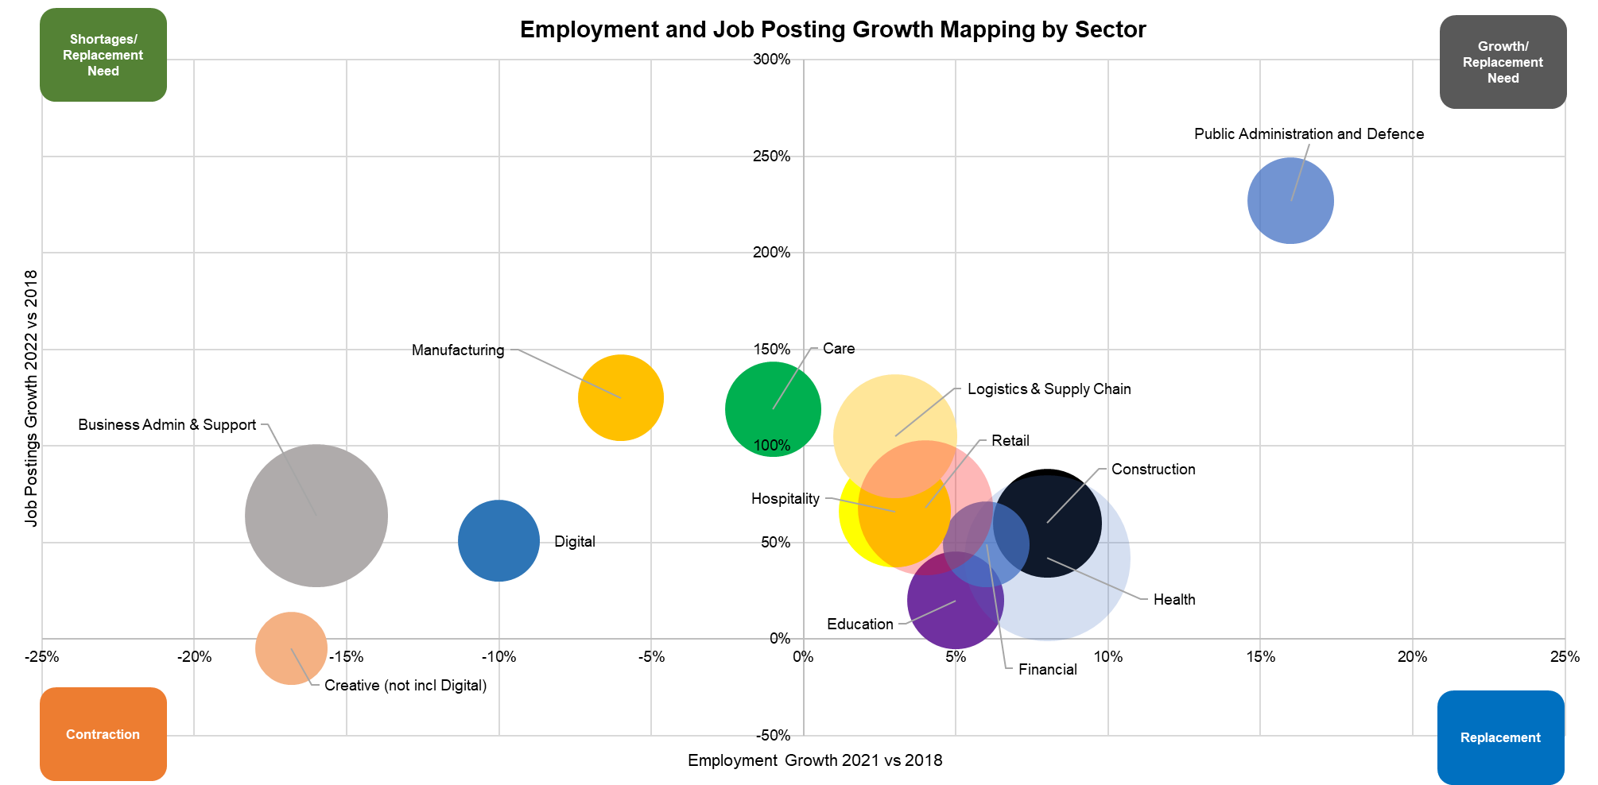
High job postings growth and high employment growth = growth of sector and/or high replacement need: Public Admin and Defence; Logistics and Supply Chain; Retail; Hospitality; Construction; Health; Education; Financial.
High job postings growth and reduction in employment = higher shortages in the sector and/or high replacement need: Business Admin and Support (mainly agencies for other sectors); Manufacturing; Care; Digital.
Demand by occupational routes and pathways and influence is reflected in the map below of employment and job postings growth 2022 vs 2018 with the size of the bubbles reflecting the job posting demand.
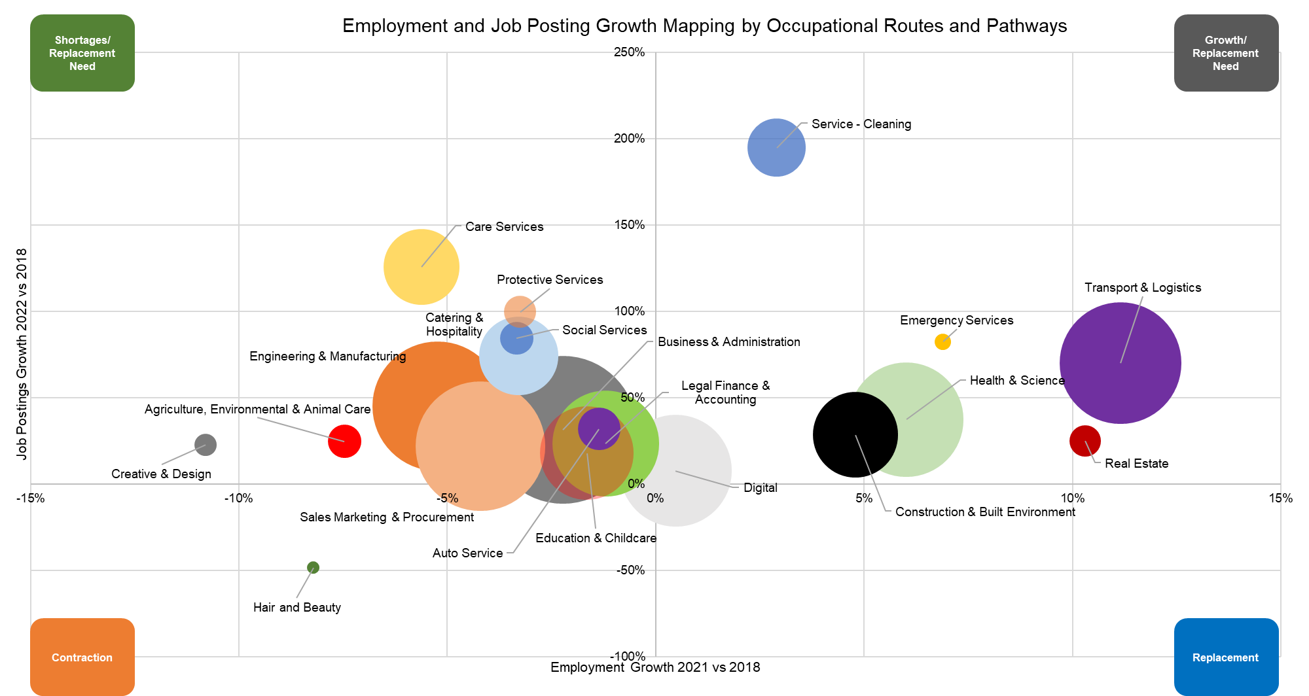
High job postings growth and high employment growth = growth of occupational routes and pathways and/or high replacement need: Transport and Logistics; Real Estate; Health and Science; Construction and Built Environment; Digital; Service – Cleaning.
High job postings growth and reduction in employment = higher shortages in the occupational routes and pathways and/or high replacement need: Care Services; Protective Services; Social Services; Catering and Hospitality; Engineering and Manufacturing; Business and Administration; Legal, Finance and Accounting; Education and Childcare; Auto Service; Sales, marketing and Procurement; Agriculture, Environmental and Animal Care; Creative and Design.
Learner achievements quotients vs job postings is mapped below for 2022 with the bubbles reflecting the learner achievement numbers for apprenticeships, further education and A-Levels combined.
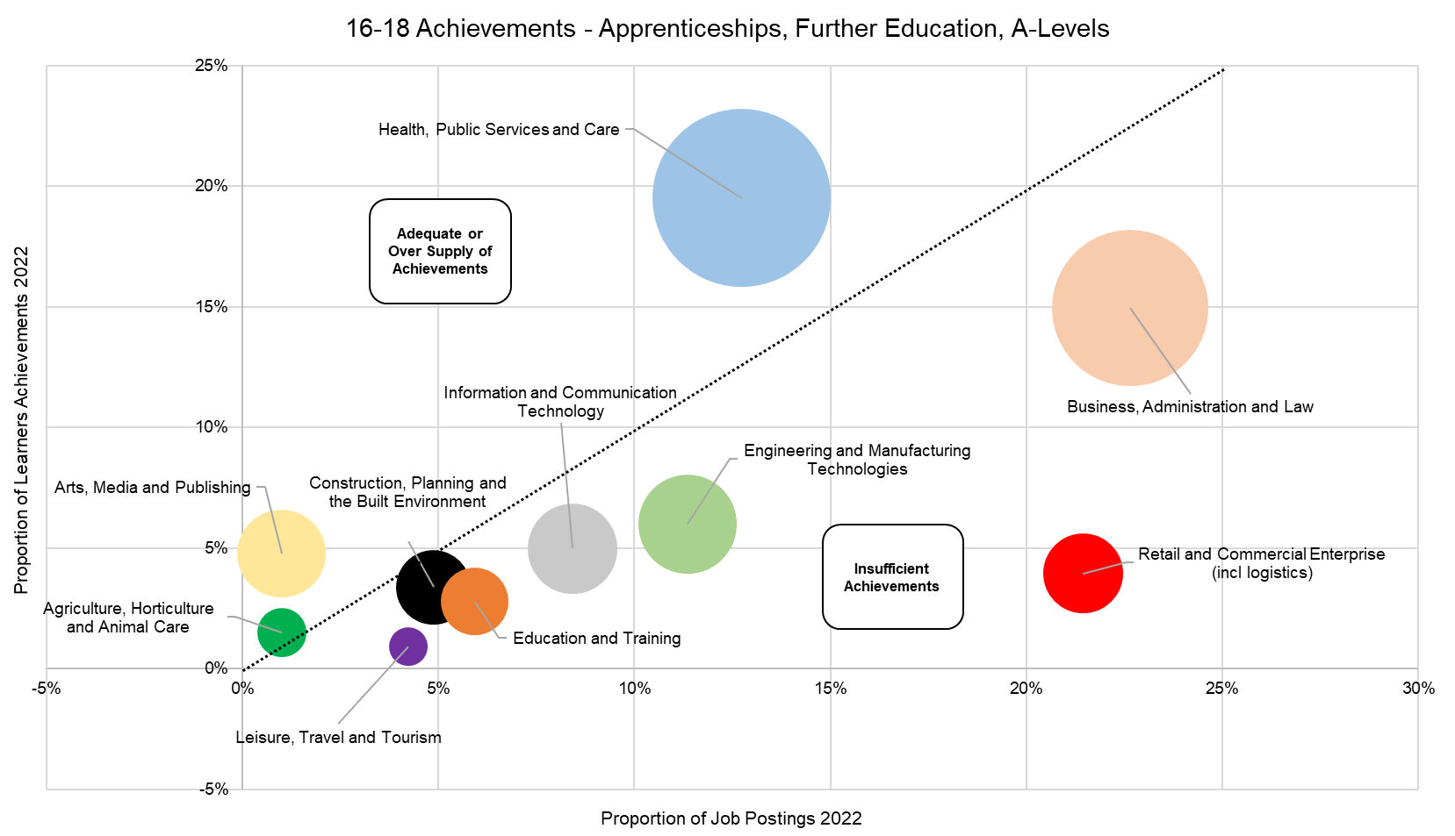
Adequate/oversupply of learner achievements versus job postings: Health, Public Services and Care; Arts, Media and Publishing; Agriculture, Horticulture and Animal Care; Hair and Beauty (not shown on chart).
Insufficient of learner achievements versus job postings: Business, Administration and Law; Retail and Commercial Enterprise (including Logistics); Engineering and manufacturing Technologies; Information and Communication Technology (Digital); Education and Training; Construction, Planning and the Built Environment; Leisure, Travel and Tourism (including Hospitality).
Why changes are needed
Employer Engagement
LSIP related employer comments and observations within the MK College Group SDF evaluation, SEMLEP Business Survey and the LSIP evaluation reports alongside direct feedback from the LSIP employer consultation and survey ₍₁₎ indicated that:
- 65% of the respondents were not currently working with any providers
- 20% were not currently working with any providers but would like to.
- 9% did not have time and/or budget to engage with training providers

The SEMLEP Business Survey ₍₂₎ showed positive actions taken/channels used by employers to increase skills were predominantly by medium and large employers. Micro and small businesses showed highest feedback for “not doing anything”:
- Offering in-house training & development 20% (medium/large)
- Not doing anything 14% (micro/small)
- Outsourcing training & development 13% (small/medium)
- On-line/remote training 7% (micro/small/medium)
- Engaging with colleges 5% (medium/large)
- Investing in apprenticeships 4% (large)
- Using agencies to recruit skilled people 1% (medium)
- Engaging with universities 1% (medium)
- Engaging with schools 1% (Micro/small)

Reasons provided for not engaging with apprenticeships were:
- Size of business is too small 18%
- Business/type of work is unsuitable for apprentices 14%
- We want to employ people that are ready to do the job 11%
- Poor experience of apprenticeships 9%
- Cost 6%
- Cannot find suitable candidates 3%

Reasons given for no engagement with providers were:
- Do not see value 23%
- Lack of time 15%
- Lack of opportunities 13%
- Concerns about the safety of students 4%
- Red tape/bureaucracy 7%

From the consultations with stakeholders and the evidence base as described above, changes are required to ensure skill/occupation shortages are addressed by the:
- Utilisation of existing provision for occupations with need through promotion.
- Introduction of provision to the occupations with need where none or little currently exists.
- Development of the introduction of new fast-track provision for occupations with need.
- Development, application and evidencing of core transferable skills, digital skills, attitudes and behaviours, both within pre and post 16 education for people.
- Efficient and effective increased engagement of employers with education.
- Clear sign posting of the occupations with need both now and in the future to young people, parents, carers, education staff and adults.
- Providing accessible pathways for individuals towards occupations with need in terms of levels of provision and addressing barriers.
- Promotion and adoption of the opening up of recruitment by employers.

Common references and themes from employers are:
- A greater industry/sector understanding.
- A robust career and educational advisory service fit for purpose, working closely with businesses to develop talent required for the future and to help individuals be invested in work suited to them and their abilities. Soft skills are as key as any.
- Better interaction with local businesses / schools and technical colleges.
- Clarity, accessibility, appropriate funding support would be a good start.
- Communication of what skills support is available is always welcome.
- Developing people that have analytical abilities and critical thinking skills.
- Inclusivity
- Industry specific help
- More access to relevant online course to our business.
- People who understand the industry, not academics
- Practical skills rather than theory
- Something that's accessible, sponsored and perhaps independently monitored
- Support in development, opportunities and funding
- Training programme for low-level entry-level jobs. Build basic skills in literacy and numeracy, professional standards and expectations, what an employer expects of you and what you can expect from your employer. Get those people into the workforce to build their skills.
- Value for money easily accessible support that is co-ordinated and supported for the company and the individual

How the LSIP can help drive change
The LSIP will drive change through cultural shift and developing and understanding of post16 provision through the delivery of priorities and support for LSIF by regional stakeholders
From employer feedback, local reports etc, there is work to do before we look at “wholesale” change of provision - and although there are stated gaps in provision, based on the top 60 occupations, lots of funded provision is in place.

We have an awareness issue that needs addressing, the other challenges we face are lack of employer engagement due to time (business model changing - over 50’s leaving, under 24’s not “job ready”), management styles, lack of understanding of post 16 funding streams etc. credibility and trust of training, how to attract talent/people and develop careers and how the skills system can be more employer inclusive.

Wherever possible we must try to influence the collaboration between industry and education provision necessary to facilitate Work Experience / Industry Placement opportunities for young people – which will be a requirement within the current qualification reforms. These reforms will put a much greater emphasis and burden on work experience as a necessary part of qualification completion.

The pandemic and current economic climate are creating a re-evaluation of peoples priorities and what work and employment should look like – research appears to be supporting hybrid approaches to work as being productive and an expectation of job applications – this type of practice (hybrid delivery of qualifications and skills) is also likely to be an expectation within adult education and training but does not seem to be as effective in delivery for 16 -18 education and training.

The world of work is changing and we need to look at how we can develop a market correction and help educate employers about why prevalent work attitudes, changing employee needs and the demand for flexibility etc. is important in recruitment and retention.

Who needs to be involved?
We will seek to partner and work with those delivering a skills based contracts (Further Education, Higher Education providers, Adult Learner, Community Learner Services within Local Authorities, National Career Service, Restart, Work and Health Programme providers) plus commissioners such as Crown Commercial Services, Ministry of Justice, Dept of Work and Pensions, Local Authorities, Dept of Education. Trade bodies, ERB’s, employers and Skills/Careers Hubs
What will success look like?
A reduction in ‘hard to fill’ vacancies and employers stating that applicants and the existing workforce have or can develop the skills needed through:

- A vocational education and training system with clear pathways so people and employers understand and can be made aware of training options and can make informed decisions about what and where provision is available.
- More flexible, portable training with corresponding micro-credentials or
accreditation where they add value, licenced to providers to mitigate the risk in
quality of delivery.
- Collaboration of stakeholders in the development of provision to meet local labour market demand including the co-designing of programmes alongside new/innovative learning methods and use of technology.
- More employers engaged and invested in all types of skills provision and training (including T levels, Apprenticeships, non-accredited, modular and vocational)
- The inclusion of the development, application and evidencing of basic skills, core transferable, attitudes and behaviours (“soft skills”) within provision. This includes their relevancy to the workplace.
- New provision and inclusion in existing provision for the development of ICT/digital skills at a basic level (email, web searches, etc) , for digital literacy for use within the workplace and business development/efficiencies (spreadsheets, digital marketing, CRM, etc) and specialist digital higher-level skills (programming, cyber security, etc).
- More people within the learner pipeline for occupations with need locally particular for STEM related occupations through changing perceptions and understanding of opportunities within sectors, existing provision and future needs – increasing learner engagement and achievements and reducing barriers to learning.
- Creating a cultural shift (thinking and acting differently) through stakeholder collaboration and the promotion of benefits and opportunities created through open recruitment, development and retention of the workforce through provision that develops management, is more flexible, accessible and relevant to employers through use of efficient use of time and content that adds value.
- Accessible and communication channels between stakeholders that add value.
- A common language of the skills system used by stakeholders.

References

- LSIP Employer consultation and survey 2023 – Annex A
- SEMLEP Business Survey 2021 – Annex E
- Focus Rationale 2023 – Annex A
- ONS, annual population survey 2022
- Job Postings 2023 – Annex E
- Employment 2023 – Annex E
- Learner Pipeline 2021 – Annex E
- Employment Predictions 2023 – Annex B
- Top 60 Occupations in Demand (Employment and Job Postings Trends/Employment Predictions/Provision – Provider Listings) – Annex E
- Top 60 Occupations and Skills – Annex G
- Business Operations and Administration Sector (including employment agencies) 2023 – Annex E
- Care Sector 2023 – Annex E
- Creative Sector (former DCMS definition) 2023 – Annex E
- Digital Sector 2023 – Annex E
- Education Sector 2023 – Annex E
- Financial Sector 2023 – Annex E
- Health Sector 2023 – Annex E
- Hospitality Sector 2023 – Annex E
- Logistics and Supply Chain Sector 2023 – Annex E
- Manufacturing Sector 2023 – Annex E
- Public Administration and Defence Sector 2023 – Annex E
- Retail and Sales Sector 2023 – Annex E
- Green Economy 2023 – Annex E

PART 2
Key Outcomes Employers Want
Employers require skills development and people with skills for:
- Recruitment – for growth, replacement need, introduction of technology.
- Upskilling/Reskilling – for staff retention, progression, CPD, diversification, changing technology.
- Development of a talent pipeline – for future recruitment, contributions to CSR/ESG.

Skills
Employers needs are for people with core transferable skills (soft skills) and digital skills with over 70% of employer responses in the LSIP Employer Consultation stating these were an issue
The most common core transferable skills were (% of occupations):

Communications 100%
Management 100%
Customer Service 92%
Detail Oriented 88%
Self-Motivation 83%
Organisational Skills 75%
Planning 75%
Sales 71%
Operations 69%
Problem Solving 68%
Enthusiasm 61%
Interpersonal Comms 58%
Leadership 58%
Time Management 58%
Microsoft Excel 42%
Microsoft Office 36%
Willingness To Learn 36%
Writing 34%
Computer Literacy 31%
Innovation 31%
Mathematics 31%

Digital skills were further defined as digital literacy, programming languages and other systems and software. The most common digital skills were (% of occupations):
Digital Literacy

Microsoft Excel 93%
Microsoft Office 90%
Microsoft Outlook 86%
Microsoft PowerPoint 80%
Microsoft Word 66%
Spreadsheets 47%
Microsoft Teams 32%

Programming Languages
SQL 31%
JavaScript 15%
Python 15%
C# or Java 12% (each)

Other Systems and Software

eClinicalWorks (ECW) 12%
Microsoft SharePoint 19%
SAP Applications 54%
Aruba (Network Mgmt) 53%
Operating Systems 29%
Microsoft Azure 24%
Warehouse Mgmt Systems 22%
Dashboard 20%
IT Infrastructure Library 20%
Accounting Software 19%
Power BI 19%
Salesforce 19%
Appl Prog Interface (API) 17%
Xero (Accounting) 17%
Active Directory 15%
AutoCAD 15%
Zoom (Video) 15%
Apache Spark 14%
Cascading Style Sheets (CSS) 14%
Amazon Web Services 14%
Occupations Shortages and Future Demand

Employers are experiencing challenges in recruiting for these top 60 occupations:

Account Manager / Representative
Accountant
Automotive Service Technician / Mechanic
Bookkeeper / Accounting Clerk
Business / Management Analyst
Buyer / Purchasing Agent
Care assistant
Caregiver / Personal Care Aide
Chef
Civil Engineer
Computer Support Specialist
Computer Systems Engineer / Architect
Construction Helper/Worker (incl. retrofit)
Credit Analyst / Authoriser
Customer Service Representative
Data / Data Mining Analyst
Delivery Driver
Electrical Engineer
Electrician (includes retrofit)
Financial Manager
Food Service Team Member
General cleaner
Healthcare Manager
HGV / LGV Class 1 Driver
HGV / LGV Class 2 Driver
Human Resources / Labour Relations Specialist
IT Project Manager
Kitchen Staff
Labourer / Material Handler
Lawyer
Maintenance Technician
Manufacturing Machine Operator
Marketing Manager
Mechanical Engineer
Nursery nurses, assistants and playworkers
Nursing Assistant / Healthcare Assistant
Office / Administrative Assistant
Operations Manager
Physician
Primary School Teacher
Production Worker
Project Manager
Receptionist
Recruiter
Registered General Nurse (RGN)
Retail Sales Associate
Retail Store Manager / Supervisor
Sales Assistant
Sales Manager
Sales Representative
Scheduler / Operations Coordinator
Security Officer
Senior Administrator
Software Developer / Engineer
Teaching Assistant
Tutor
University Lecturer
Utilities Technician (includes retrofit)
Warehouse / Inventory Associate
Welder / Solderer

Occupations and Pathways

Feedback from the LSIP employer consultation and survey indicated:
- A preference for provision that has been designed and includes input from business people from the relevant sector.
- A relationship with training providers who understand the needs of the sector providing training relevant to the business (53%).
- 51% positive response to the use of online training courses and qualifications.
- Over a third (35%) support accredited short modular courses (not full qualifications) and a mix of work/college based provision.
- 31% sought full qualifications.
- Additional comments made by over 40% of respondents included preferences for ‘on the job’ and/or ‘flexible and accessible and bite size’ provision.
- A desire for tutors that have up to date knowledge of the relevant sector (40%).

Provision pathways exist locally for the 60 occupations with a few exceptions as listed below where provision either does not exist or is limited:
- Account Manager/Representative - limited specialist provision in place from level 3.
- Automotive Service Technician/Mechanic - limited specialist provision in place for electrical vehicle maintenance.
- Buyer/Purchasing Agent - limited specialist provision in place from level 3.
- Delivery Drivers - non DfE funded provision in place as per HGV/LGV.
- HGV/LGV Class 1 and 2 Drivers - non DfE funded provision in place through independent training providers.
- Labourer/Material Handler and Warehouse/Inventory Associate - limited DfE funded provision in place. The private sector is addressing locally with the establishment of sector focused academies and provision.
- Marketing Manager - limited specialist provision in place from level 3.
- Production Worker - specific provision need for electric vehicle manufacture, increasing technical roles in food production and CNC operation.
- Project Manager - limited specialist provision in place from level 3.
- Scheduler/Operations Coordinator - limited specialist provision in place.
- Security Officer - limited specialist provision in place.
- Utilities Technician/Electrician - limited specialist provision in place for green economy related especially related to retrofit.

With the shortage of applicants from with the ‘tight’ labour market due to the shortage of people, the immediacy of demand is requiring short, focused provision. This also places pressure on time within a business and the need for people to be ‘on the job’ or utilising their own time for CPD/upskilling
Close to 50% of the employers who participated in the consultation or survey would invest both financially in skills (48%) and using staff to help develop courses (47%) assuming that both the courses are relevant to the role and any cost relevant to the size of the business. For smaller businesses both time and cost prohibit support
Engagement of Employers
From the LSIP employer consultation and survey, employers indicated:
- A desire for relationships with training providers who understand the needs of the business sector (53%).
- Training that is relevant to the business (47%).
- A need for easy access to local training to upskill staff (42%).
- Awareness of what provision is available (46%). Comments from 39% of the respondents stated it was difficult to find/keep up to date with what was available and a desire for a centralised resource.

When asked what would work in the sector in an ‘ideal world’ the main responses were:
- Awareness of what financial support is available and increases where necessary (72%).
- Better basic skills before leaving school, such as IT, English and Maths (15%).
- A need to look inside their own businesses, valuing staff by investing and developing from within (7%).

Occupations and Skills for the Future
Employers were asked to consider which skills/roles their business would need over the next 5 to 10 years. The responses were:
- IT and digital (45%)
- Sector specific or technical (42%)
- Roles related to support environmental goals (22%), decarbonisation (13%)
- Soft Skills (21%)
- Green technologies (20%)
- Automation and robotics (18%)
- Other (14%)

With the recognition that there needs to be more engagement with a number of sector leads, independent training providers and employers in our region to discuss challenges and skills needs, occupations/skills need by occupational routes and pathways discussed from data gathered from a range of employer feedback, conversations, consultations, LSIP Consultation, other ERB’s and surveys:
- Business & Administration - Leadership/Management, Project managers; Planning/ scheduling. Effective business, leadership and management skills are crucial for organisations to drive growth and innovation. There is a demand for skilled managers who can lead teams, make strategic decisions, and adapt to changing business environments.
- Catering & Hospitality – Hospitality, butchery and customer facing skills.
- Sales Marketing & Procurement - International trade documentation; Marketing; Sales; Customer service, leadership.
- Logistics: We have demand for Industry based training (e.g. Fork Lift Truck and Warehousing) but there is also a growing demand for training to satisfy the growth in automation, IT based planning and fleet sustainability
- Digital Skills: The demand for digital skills cuts across industries. There is a shortage of skilled professionals in areas such as cybersecurity, data analysis, software development, artificial intelligence, and digital marketing. The rapid advancement of technology requires ongoing upskilling to meet the evolving needs of the digital economy.
- STEM (Science, Technology, Engineering, and Mathematics) Skills: There is a shortage of skilled workers in STEM fields, including engineering, computer science, mathematics, and physics. The UK needs a pipeline of STEM talent to support innovation, research and development, and the growth of high-tech industries.
- Creative Industries: The creative industries, including film, television, design, and gaming, face skills gaps in various roles such as animation, visual effects, game development, and content production.
- Financial Services: The financial services sector requires skilled professionals in areas such as risk management, financial analysis, compliance, and financial technology (fintech). There is a need for individuals with a strong understanding of complex financial systems and regulations.
- Construction, Built Environment and Trades: Entry routes into the insulation and renewables sector; Solar, PV, electric vehicle charging, energy storage, design, contract management; Electro technical electrification and net zero. There is a shortage of skilled workers in the construction industry and trades such as carpentry, plumbing, and electrical work. The demand for housing and infrastructure development requires a skilled workforce to meet the construction needs across the country.
- Health and Social Care: The health and social care sector faces significant skills gaps, particularly in nursing, general practitioners, social care workers, and mental health professionals. The aging population and increasing demands on the healthcare system have contributed to these shortages alongside administration of electronic records and use of ICT
- Advanced Manufacturing and Engineering – It is recognised that the UK's advanced manufacturing sector requires skilled workers in areas such as robotics, automation, additive manufacturing, and advanced materials alongside Engineering; Manual/CNC machining; Design Engineers; Service personnel and fitters. There is a need to work closer with this sector to identify how we can bridge the skills gap in these technologies to drive innovation and competitiveness, including those needed in Automotive Engineering and associated new technologies - Autonomous Drive, EV motors, High Voltage Li Batteries, Connected Car/Infotainment.

Linked to many sectors (construction, logistics, manufacturing, agricultural, food and drink etc) are Green and Sustainable Skills: As the UK transitions to a low-carbon economy, there is a growing demand for skills in renewable energy, energy efficiency, sustainable construction, and environmental conservation. The skills gap in these areas hinders progress in achieving sustainability goals which we need to address

Proposed Provision Requirements
Whilst the majority of occupations with current need and those predicted to have increasing demand in the future have provision/pathways available locally, the list below highlights both existing DfE funded provision that could be used and suggestions of new provision for those occupations with limited or no pathways in the South East Midlands:

Proposed Provision
Apprenticeships | Level
Urban driver | Level 2
Large goods vehicle lgv driver c + e | Level 2
Supply chain warehouse operative | Level 2
Express delivery sortation hub operative | Level 2
Express delivery operative | Level 2
Food and drink process operator | Level 2
Lean manufacturing operative | Level 2
Professional security operative | Level 2
Commercial thermal insulation operative | Level 2
Construction assembly and installation operative | Level 2
Motor Vehicle Service and Maintenance Technician (Light Vehicle) | Level 3
Digital marketer | Level 3
Marketing assistant | Level 3
Machining technician | Level 3
Food and drink technical operator | Level 3
Security first line manager | Level 3
Industrial thermal insulation technician | Level 3
Low carbon heating technician | Level 3
Refrigeration, air conditioning and heat pump engineering technician | Level 3
Sales executive | Level 4
Market research executive | Level 4
Marketing executive | Level 4
Public relations and communications assistant | Level 4
Associate project manager | Level 4
Logistics operations warehousing manager | Level 4
Business to business sales professional | Level 6
Digital marketer | Level 6
Marketing manager | Level 6
FE Full-Time | Level
Maintenance, installation and repair for engineering and manufacturing - Light and Electric Vehicles | T Level
Food and drink technical operator | T Level
Installation and maintenance electrician | T Level
Refrigeration, air conditioning and heat pump engineering technician | T Level
Plumbing and domestic heating technician - Environmental Technologies | T Level
Domestic, Commercial & Industrial Electrical Vehicle Charging Equipment Installation City & Guilds | Level 3
Installation & Maintenance of Small Scale Solar Photovoltaic Systems City & Guilds 2399-12 | Level 3
Domestic Electric Vehicle Charging Equipment Installation | Level 3
Provision will need to be considered for:
- Retrofit assessors
- Retrofit coordinators
- Retrofit designers

Converter Provision - Short courses/training to upskill/reskill
- Account Manager/Representative
- Marketing Manager
- Project Manager
- Scheduler/Operations Coordinator
- Security Officer - limited specialist provision in place.
- Utilities Technicians (including Electricians, Plumbing, Heating, Green Energy and Retrofit)
Modular Provision
- Sales for micro/small businesses
- ESOL for business
- Digital marketing for micro/small businesses
- Microsoft Excel - application
- Critical Thinking
- Entrepreneurship/Enterprise
- Communication – written with Microsoft Outlook and Word
- Communication – presentations with Microsoft PowerPoint
- Financial capability
- Leadership
- Others - to be identified

The above would be subject to approval for suitability by employers and educators with particular focus placed on micro, small and medium enterprises (SME) as the evidence shows they are least likely to engage yet account for 98% of local enterprises and 48% of employment.

We estimate that 30,000 people, approximately 3% of the workforce, have withdrawn from the labour market since 2020 due to the reasons listed in “Occupation Shortages”. All existing provision should be further reviewed considering the immediacy of demand for top 60 occupations and the provision suitability to meet that need.
Focus also needs to be placed upon the development, application and evidencing of core transferable skills, digital skills, attitudes and behaviours. Based on the above information these are defined as:
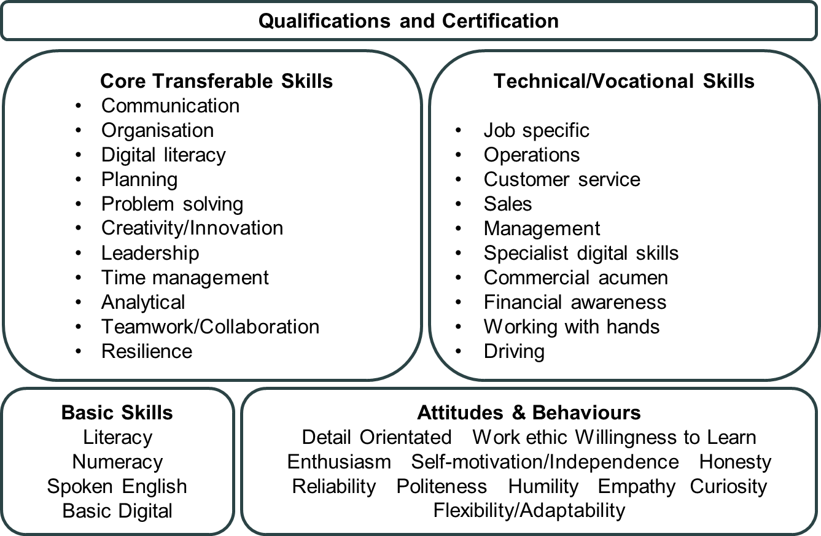
Digital literacy is further defined as the use of Microsoft Office software predominantly: Excel; Outlook; PowerPoint; Word; Teams. Basic digital is defined as being able to search online, access a bank account and sending/receiving emails.

Spoken English includes English for Speakers of Other Languages (ESOL). Specific skills required for each occupation are listed in Annex E: Top 60 Occupations and Skills.

Part 3

Explain what needs to happen to bring about change

Details of proposed provision, identified draft priorities, desired outcomes and the draft delivery roadmap are contained in the Annexes – the main areas from these to consider are as follows:

- Colleges and Training providers need to provide the high calibre staff resources for delivery – there is an urgent need to enable dual professional status and develop an attractive career choice, bringing industry experience and skills into the classroom / workshop – we need to develop skilled industry practitioners into skilled teachers/ Dual Professionals

- We need to explore how we can have proper recognition of transferable skills – if the attitudes and behaviours of young people meet employer expectations it is always worth exploring the technical / vocational skills candidates have which very often can be adapted / developed to fit what might be perceived as a non – aligned job role initially.
- We need to consider how we can develop a “joined up” approach between JCP and providers (including ITP and Local Authorities) relating to joint information accessibility, Adult Learning Systems, learner training prospects (does training directly contribute to a person’s employment / career progression etc) and required JCP commitments as courses and support offered by JCP and FE are often not known to each other and organisations timetables can often clash, leading to reduced/ lower attendance and impacts on both learning and teaching.

- Colleges and Training Providers have invested in facilities and kit to closely replicate contemporary industry practice and environments – such facilities have been enhanced recently via initiatives such as SDF collaborative projects. We now need to explore how these facilities in our region can be maximised for up-skilling / re-skilling courses for adults who would be interested in career progression or career change education and training. Previous funding stimulated this route to skills development which ensured the resources and facilities were utilised equally well through evening classes as through day time classes. We will explore collaboration in both course design and regional employer engagement, offering skills brokerage, information etc.

- Many applicants are not able to (and will not be likely in the near future) be able to meet essential criteria for Maths and English stated on apprenticeship vacancies. This is especially valid in practical trades, though not just limited to them. More research is needed into why this is, what is driving this and then resolve to open the opportunity up to many who are extremely motivate and talented in specific sectors, though not necessarily in Maths and English qualifications. We need to identify if Multiply can support preparation for Apprenticeships. Construction Apprenticeships have a specific issue in that many Apprentices move from site to site during the length of their Apprenticeship, causing logistical and practical challenges to delivery and achievement rates. We need to consider exploring the use of rotational Apprenticeships as one way of how this issue can be minimized

- Navigating the skills system – providers have fixed funding and delivery guidelines and we need to explore ease of access to more flexible and meaningful provision. Most training available to employers is offered as a product within these guidelines, we need to explore how they can be part of a “transactional sale” and be more relevant. Linear progressions within some Occupational Pathways are not always available and we need clarity on the variety of career opportunities within Pathways where this happens. A progression map of skills courses leading to careers and a range of learner destinations will support this

- We need to consider how we can tie in the links to environmental / carbon reduction necessities within the skills areas identified (e.g. Electrical / HVAC / Plumbing – education and training around renewable energy sources and sustainability, Haulage / Logistics – Hydrogen fuel cell / electric vehicle transportation right down to last mile delivery). We need to understand how to offer these in parallel to existing provision

- We need to review how we can increase ESOL provision that can also be delivered in parallel to Careers, Advice and Guidance and explore / experience within work settings.

- We know there are challenges to bringing about the changes identified, and we will need to explore and investigate these further with all stakeholders throughout the lifetime of the LSIP (and LSIF) projects. When planning next steps, we also need to consider the range of responses we received and look though comments wherever possible for improvement (only 51% stating they had a positive response to online training, 9% of employers said that had a bad experience of apprenticeships and 4% of employers stated that they had concerns about the safety of the students).

Actions proposed to take forward priorities
Detailed below are the LSIP Priorities and proposed Roadmap/actions. These priorities and proposed actions, whilst stated as separate responses to questions asked do have over-lap and will be looked at to identify potential LSIP focused projects within the Local Skills Improvement Fund (LSIF).

As part of the ongoing LSIP (and LSIF and mainstream funding) deliverables, we will look to have working groups to implement the occupational pathways and skills where actions are needed - these could be Employer Sector groups or Occupation groups across Colleges/providers – or a mix.

This infrastructure will both define our Agenda for action in terms of local system priorities, occupations and skills and provide a clear mechanism for implementing these which we will (as ERB) look to lead and co-ordinate.

This also provides our mechanism for monitoring and measuring progress.

From the consultations with stakeholders and the evidence base, the draft priority and roadmap actions detailed below are required to ensure skill/occupation shortages are addressed by the:

- Utilisation of existing provision for occupations with need through promotion.
- Introduction of provision to the occupations with need where none or little currently exists.
- Development of the introduction of new fast-track provision for occupations with need.
- Development, application and evidencing of core transferable skills, digital skills, attitudes and behaviours, both within pre and post 16 education for people.
- Efficient and effective increased engagement of employers with education.
- Clear sign posting of the occupations with need both now and in the future to young people, parents, carers, education staff and adults.
- Providing accessible pathways for individuals towards occupations with need in terms of levels of provision and addressing barriers.
- Promotion and adoption of the opening up of recruitment by employers

Priority 1:
A priority is to help businesses, particularly SMEs, to identify new shifts in business needs and to understand, develop, work with and take advantage of skills provision available through identified future technologies (and developments in practice) as well as new technologies already being used or available.

Desired Outcomes:
• More businesses engaged for skills provision and training
• More agile and nimble local skills system with defined, clearer roles
• More shared strategic thinking
• More suitable and more flexible training opportunities
• Employers have a clearer skills/career path for their workforce
• Barriers to learning are understood with a clear path for implementation

Proposed Actions:
- ICT/digital skills across many business areas (including sales, management, leadership, critical thinking etc) are critical to the future of most jobs with the emergence of specialist skill areas. We need to measure the relevance of existing provision, promote what is available in a way that is understood by service users and achieve real growth in transferable/digital skills. Introducing STEM subjects for longer, incorporating these skills alongside regular studies and investing earlier in digital skills in the education system would support this skills need.

Priority 2:
A priority is to work with employers and stakeholders to identify why existing “soft skills” provision may not be relevant to the changing (post covid) workplace and how “readiness for work and essential skills for work – communication, attitude, resilience, problem solving etc”) can be effectively developed and evidenced within academic, technical and vocational provision. We need to change language, moving from “soft skills” to “core transferable, attitudes and behaviours” etc. in an easily, commonly understood way

Desired Outcomes:
• More businesses engaged for skills provision and training
• More agile and nimble local skills system
• More shared strategic thinking
• Growth in personal development
• More learners
• More suitable and more flexible training opportunities
• Barriers to learning are understood with a clear path for implementation
• ESOL and Business language skills

Proposed Actions:
- Our Education and training system needs to teach broad concepts and clearly articulate what “soft” or “critical” or “foundation” skills are (for example - Communication, Collaboration, Creativity, networking, problem-solving, literacy, numeracy skills etc etc).and how they are relevant to the workplace
- Provide a tool to employers to allow them to identify their skills gaps
- Fund opportunities to experience work (similar to the Kickstart programme)
- Promote existing (embedded) skills, values and behaviours to learners and business

Priority 3:
A priority is to raise awareness of existing provision that satisfies demand in a way that employers understand and to continue to map provision against job demand and employer skills challenges so that further identified gaps in provision can be made available. This includes getting greater collaboration between colleges and Independent Training Providers. As part of this, a number of employers working closely with Further Education that provide skills training that meets their needs were positive about extending and further developing this work.

Desired Outcomes:
• More businesses engaged for skills provision and training - specifically what, and at what level, what type of provision etc
• More agile and nimble local skills system with clearer roles
• More shared strategic thinking
• Growth in earnings and in personal development
• Up to date skills in sectors that are growing and changing
• More learners
• More suitable and more flexible training opportunities
• Employers have a clearer skills/career path for their workforce
• Barriers to learning are understood with a clear path for implementation
• ESOL and Business language skills

Proposed Actions:
- Sign post employers to what is available already - work regionally - go beyond simply passing the buck from one provision to another (Train to Gain)
- Work with employers to contextualise the generic qualifications.
- stakeholders to implement the growth and new pathways in occupations
- Use more approved CIAG providers and recognise “basic” skills courses to enable progression
- To review and grow volumes in the occupations where there is provision demand

Priority 4:
A priority is providing accessibility and flexibility of training opportunities. Alongside this is a priority to engage with employers to identify how these can continue to be relevant

Desired Outcomes:
• More businesses engaged
• More learners
• More suitable, agile and flexible skills system and training opportunities
• More shared strategic thinking
• More collaborative working and/or bids for funding
• More skills in sectors that are growing and changing

Proposed Actions:
- Any future vocational education and training system needs to provide clear and more flexible pathways so that workers are well aware of training options and can make informed decisions about what to do and how to do it. Change the perception and understanding of existing provision and future needs – contributing to learner engagement and achievements and reducing barriers to learning - with a clear path for implementation.
- Review provision of delivery beyond term time / 9-5 delivery
- Promote existing opportunities
- Collaboration between training providers and employers
- Collaborate with partners to review potential provision similar to DWP “SWAP” model

Priority 5:
A priority is to communicate and engage with employers who haven’t been working with colleges, chambers, LEPs on their skills needs to develop a real understanding of how education and training works in England, what is available in their local area in a language they understand and how they can benefit from engaging with training providers to access the provision already available

Desired Outcomes:
• More businesses engaged
• More agile and nimble local skills system
• Clearer roles in the skills system – educating employers clearer understanding of pathways & language
• More collaborative working including bids for funding
• More skills in sectors that are growing and changing
• Responsive curriculum offer
• Retaining and retention of staff – cultural shift
• Simplified funding landscape from DofE
• Openness for stakeholders to work as partnerships – collaboration of partners
• More suitable and more flexible training opportunities

Proposed Actions:
- The current economic climate and pandemic is altering the perception for many of what work and employment should look like – research appears to be supporting hybrid approaches to work as being productive and an expectation of job applications – this type of practice (hybrid delivery of qualifications and skills) is also likely to be an expectation within adult education and training but does not seem to be as effective in delivery for 16 -18 education and training. An action is to understand user needs and available provision
- The world of work is changing and an action is that we need to look at how we can develop a market correction, helping educate employers about why prevalent work attitudes, changing employee needs and the demand for flexibility etc. is important in recruitment and retention.

Priority 6:
A priority is to engage with more existing niche/key employers in local areas on their particular skills needs to highlight provision, develop a ”blended” business and learning language and bring up to date, relevant skills into FE. A number of employers expressed the view that it important that existing relationships are also supported

Desired Outcomes:
• Growth in earning/person
• More skills in sectors that are growing and changing
• More learners
• Responsive curriculum offer
• Simplified funding landscape from DofE
• More businesses engaged
• More agile and nimble local skills system
• More suitable and more flexible training opportunities

Proposed Actions:
- Wherever possible we must try to influence the collaboration between industry and education provision necessary to facilitate Work Experience / Industry Placement opportunities for young people – which will be a requirement within the current qualification reforms. These reforms will put a much greater emphasis and burden on work experience as a necessary part of qualification completion.
- A broad range of stakeholders should be involved in developing courses and training to meet local labour market demand.
- We can explore workforce development planning by employers, co-designing programmes alongside new/innovative learning methods.
- Explore shared industry specific networks so that employers and providers know where to engage

Priority 7:
A priority is to look at how employers can both work with FE (and ITP’s) to build capacity to support delivery and also where the value of training is recognised so that some costs can/should be met by employers

Desired Outcomes:
• More businesses engaged
• More agile and nimble local skills system
• Clearer roles in the skills system
• More shared strategic thinking
• More collaborative bids for funding
• More skills in sectors that are growing and changing
• More learners
• More suitable and more flexible training opportunities

Proposed Actions:
- More flexible, portable training with corresponding micro-credentials could be accompanied by accreditation and licensing of providers to mitigate the risk in quality of qualifications obtained in this way.
- Employer pilots to showcase ROI - Ambassadors
- Amend the language to ensure businesses and provision understand each other
- Review provision of delivery beyond term time / 9-5 delivery
- Collaborative delivery - where provision allows

Priority 8:
A priority is to look at the development and availability of capital and human resource in partnership with sector specialists, supporting employers working on green/sustainable/decarbonisation projects or those who have recognised “green” jobs to interact with SME’s and support knowledge transfer about what “green jobs” are, facilitating an understanding of future skills needs in this area. Also to work with SME’s to help them think strategically about future skills needs and recruitment in these areas, including accessing wider groups of people such as those at risk of exclusion in order to build skills and enter further education, training, and employment.

Desired Outcomes:
• More businesses engaged
• More agile and nimble local skills system
• More shared strategic thinking
• More skills in sectors that are growing and changing
• More suitable and more flexible training opportunities
Proposed Actions:
- A cultural shift (thinking and acting differently) through stakeholder collaboration, open recruitment (gender balance, inclusion of marginalised groups, recognition of changing work patterns, management styles, flexible, accessible learning, relevance of provision to employers (time, content based etc.)
- Increase awareness from primary school age
- Give these terms “real meaning” to people
- Keep the "language" simple and understood by everyone
- Help employers to “look forward”

There are also bigger, more systemic challenges around the perception of what the provision offer actually means. We need to demystify the perceptions of learner, employer, provider and stakeholder “identity and brands” by potential service users. Terms such as “green jobs”, “soft skills” etc. are often mis-understood and detract from take-up. We need to collaborate and explore how we make “training” more attractive and how we can help potential service users to understand what is really on offer to them, bringing provider, employer and learner “languages” closer.

Employers, Providers and Learners “see” skills from 3 different perspectives (see Venn Diagram). We need to develop a cohesive, clearly articulated and commonly understood language set and understand what we mean by “skills” in order to bring these 3 areas closer together and provide effective and relevant learning for more people.

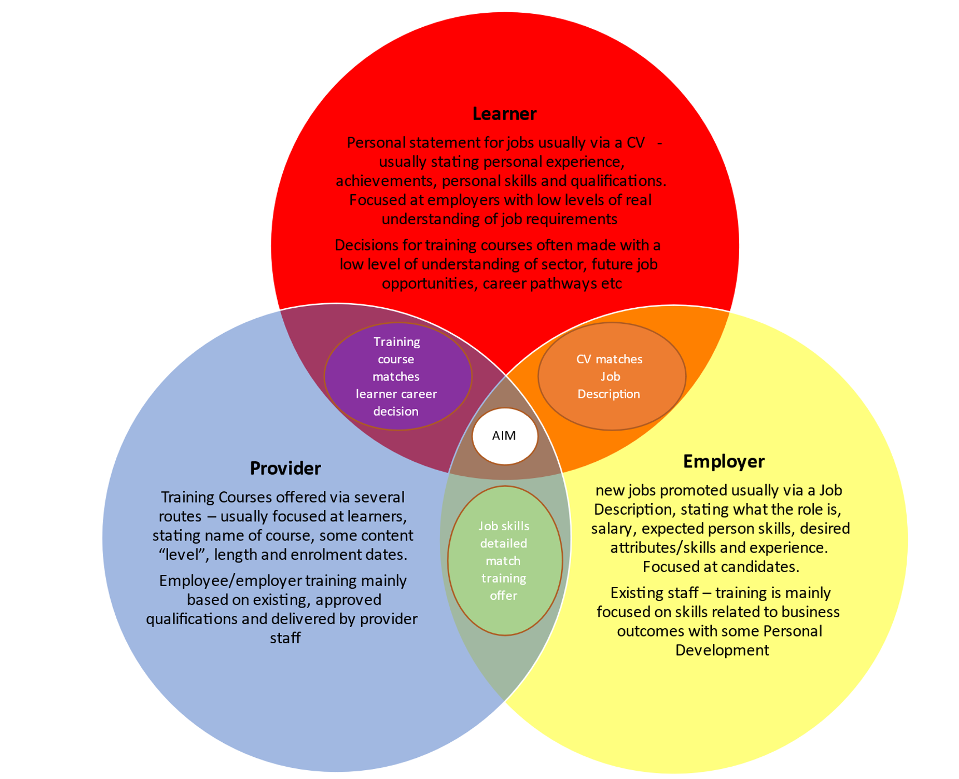
Increased engagement with key regional sectors (leads and employers) and regional independent training providers will also add to the breadth of insight regarding skills issues facing our businesses and we need to ensure that as many of these stakeholders are actively included during the lifetime of the LSIP (and LSIF).

Describe the process for effecting delivery, reviewing progress and realising expected benefits

As well as updating our existing plan for review by our Executive Group, we will be following DfE Guidelines and prescribed contract management principles to ensure effective delivery of the LSIP through its lifecycle.

- Clear and Concise Communication between stakeholders
- Clear project plan that outlines the objectives, roles and responsibilities, timelines, and resources required for successful contract management.
- Quarterly review meetings with Stakeholders
- Risk Assessment and Mitigation Plan
- Engagement with specialist groups as needed
- Account Management and continued senior staff involvement
- Regularly monitor and evaluate expected outcomes
- Establish key performance indicators and regular review and reporting mechanisms to assess compliance and identify any deviations or issues.
- Change Management Plan
- Stakeholder Management, progress reporting, updating, communications etc between employers, providers and stakeholders
- Accurate and up-to-date contract records, including all supporting documentation, correspondence, and audit trail.
- Regular review of contract management processes and practices to identify areas for improvement.

We will also look to engage with more sector leads and independent training providers and set up employer/provider working groups to support the implementation of both LSIP and LSIF actions.

Going forward, employer needs and provision available will continued to be reviewed and updates provided to stakeholders.
As stated, as part of the ongoing LSIP (LSIF and mainstream funding) deliverables, we will look to have working groups to implement the occupational pathways and skills where actions are needed. This infrastructure will both define our Agenda for action in terms of local system priorities, occupations and skills and provide a clear mechanism for implementation as well as measuring and monitoring progress.
Results and Benefits will also be measured by numerical changes, changes in views/perceptions etc by qualitative and quantitative data at beginning and end and agreed success metrics.

SEMLEP Local Skills Improvement Plan
Annexes

Index:

- Annex A – LSIP employer Consultation
- Annex B – Draft Priorities and Roadmap
- Annex C – Power BI (responses)
- Annex D - Methodology
- Annex E - Reports
- Annex F – External Referencing
- Annex G – Top 60 Occupations
- Annex H – Provision needed

Annex A

LSIP Employer Consultation(s)
The LSIP Consultation and Survey responses are shown below. The percentages shown are for the proportion of c.418 businesses and organisations. (See Annex B – Power Bi for graphics of comments to each question) and Annex E for additional supporting reports.)

What are the specific skills and competencies you need in the workplace but are struggling to find?
Soft Skills | 46%
Other | 42%
Organisation specific | 37%
Leadership/ Management | 24%
IT | 21%
English | 14%
Maths | 14%
Net Zero, Environmental | 11%
Comments
Soft and transferable skills are an issue. | 93%
They have the basic skills, but we then need to upskill on specialities. | 4%
Retention is the real problem | 2%
They are overqualified for my roles | 2%
They look good on paper but cannot do the role in reality. | 1%

Skills and competencies need by sector

Sector | Soft Skills | Organisation specific | Leadership/ Management | Digital | English | Maths | Net Zero, Environment
Agriculture/Land | 60% | 40% | 40% | 0% | 0% | 0% | 0%
Construction/Built Environment | 9% | 48% | 12% | 9% | 0% | 3% | 15%
Creative/Media | 47% | 29% | 6% | 6% | 24% | 18% | 6%
Digital/ICT/Cyber | 50% | 30% | 20% | 30% | 10% | 10% | 0%
Education/Childcare | 48% | 31% | 31% | 31% | 15% | 17% | 22%
Energy/Renewables | 67% | 67% | 0% | 0% | 67% | 33% | 0%
Entertainment/Music/Fashion | 80% | 60% | 60% | 40% | 40% | 40% | 40%
Financial/Professional Services | 53% | 42% | 25% | 29% | 16% | 18% | 11%
Food/Beverage | 58% | 25% | 33% | 17% | 25% | 33% | 17%
Health/Care | 29% | 35% | 24% | 18% | 0% | 0% | 6%
Hospitality/Tourism/Visitor Economy | 38% | 13% | 38% | 0% | 25% | 0% | 13%
Logistics/Transport | 50% | 42% | 46% | 25% | 17% | 17% | 13%
Manufacture/Engineering | 35% | 53% | 26% | 12% | 5% | 12% | 5%
Public Sector | 83% | 44% | 33% | 39% | 28% | 22% | 17%
Retail | 58% | 8% | 17% | 8% | 8% | 0% | 8%
Other | 44% | 32% | 20% | 19% | 14% | 13% | 5%
Overall | 46% | 37% | 25% | 21% | 14% | 13% | 11%

Comment common references and themes

Attitudes and behaviours
- Attitudes to work
- Good work ethic
- Reliability
- Personality
- Working on own
- Willingness to learn

Core transferable skills
- Analytical skills
- Common sense and the ability to speak with people
- Planning
- Commercial acumen
- Driving skills for mobile jobs
- Dexterity, manual skills
- Employability, workplace understanding, mental resilience
- Financial Awareness
- Lack of b2b communication skills; lack of phone etiquette skills - led often by 'confidence'
- Proactiveness, creative thinking, problem solving
- Telephone skills
- Working more as a team and communication within the team

Vocational/Technical skills
- Common technicalities
- Construction expertise
- Practical skills
- Artificial intelligence
- Electrical
- Technical
- Engineering
What types of training provision do you consider would be best suited to your organisation to meet your needs?
Courses that have been designed and include input from business people from your sector | 51%
Online training courses and qualifications | 51%
Access to accredited short modular courses (not full quals) | 35%
A mix of work/ college based | 35%
Full qualifications | 31%
Non-accredited courses | 18%
Other | 14%
Comments
On the job works for our business | 41%
It needs to be flexible and accessible and bite size (Short, Modular) | 40%
Real life experience with a good attitude | 11%
Must be practical and hands on | 8%

Comment common references and themes

Preferred formats
- A mix of online and in person training at place of work
- Depends on the role
- Apprenticeships and on the job
- Face to face
- In house
- Work experience and job shadowing

Other comments
- A training and development tax credit is needed
- No to online - IT literacy in workforce is low
- It's our Leaders and managers that need the training in their mind set

What would help you to engage with training providers?
A relationship with training providers who have an understanding of the needs of your business sector | 53%
Training that is relevant to my business | 47%
Awareness of what is available | 46%
Easy access to local training on offer to upskill staff | 42%
Tutors that have up to date knowledge of your sector | 40%
Other | 10%
Comments
It's hard to find/keep up to date with what's available for me. We need something centralised. | 39%
It would be good to have better relationships with providers to know what they are offering and what we need from them. | 30%
I need more relevant courses for my business then what's currently available | 23%
I feel that tutors knowledge is out of date. | 8%

Comment common references and themes

- Already do
- No barriers - plenty available
- Forum for Networking and Knowledge Sharing
- Provider directory
- Funding and costs
- Reduce the red tape and paperwork
- Time management

Which skills/roles do you feel your business will need to consider over the next 5 to 10 years?
IT and digital | 45%
Sector specific or technical | 42%
Roles that directly contribute to or indirectly support environmental goals | 22%
Soft Skills | 21%
Green technologies | 20%
Automation and robotic operations | 18%
Other | 14%
Decarbonisation | 13%
Comments
We need to look at more digital and automation for the future. | 36%
We will rely heavily on soft/professional skills over the coming years. | 31%
We are going to need to look at more green/environmental roles in the coming future | 28%
We need multi skilled people | 5%
Comment common references and themes
- Automotive Engineering and associated new technologies - Autonomous Drive, EV motors, High Voltage Li Batteries, Connected Car/Infotainment.
- Engineering
- Manual and CNC machining (scarce availability)
- Design Engineers
- Service personnel and fitters
- Project managers
- Entry routes into the insulation and renewables sector
- Solar, PV, electric vehicle charging, energy storage, design, contract management
- Electro technical electrification and net zero
- Health, social care and specialised courses.
- Care – administration of electronic records and use of computers
- International trade documentation
- Marketing
- Sales
- Leadership and Management
- Planning and scheduling
- Skilled Trades
- Customer service, leadership
- Cyber security
- Data sciences
- Financial
- Hospitality and customer facing skills

Would you invest in skills that will support your company?
Yes, in monetary terms | 48%
Yes, in terms of staff being involved in developing courses | 47%
No, we would struggle to give staff time to be involved in developing or delivering courses | 11%
No, we would struggle to pay for training courses | 11%
Other | 10%
Comments
We already invest time and or money into skills. | 46%
We already invest time and money but as on the job or in-house training | 25%
Why wouldn’t I? | 19%
We don’t need to do this. | 10%

Comment common references and themes

- Already do
- Courses would need to be relevant to role
- Concerns from line managers of upskilling talent to then lose it
- Depends on cost relevant to my business.
- Invest in critical skills. Need money for other training
- Its more about value
- We have a small training budget
- We would need to see training costs as an investment in future growth and build in additional capacity at the start
- No, the time to train start is often difficult.
- No, time and cost problems.
- No time investment for internal training.
- No, I am a startup business/I work on my own

Does your organisation require staff to have any of the following?
Mandatory training | 46%
Professional qualifications | 41%
Licence to practice qualifications | 24%
None | 17%
Other | 8%
Comments
We don't need specific qualifications but will have to do in-house training and job specific training. | 43%
You must have a qualification in the industry to work for us. | 38%
You need a qualification, but you can gain it on the job | 13%
Qualifications would be useful, but they are not always needed. | 6%

Comment common references and themes

- AAT (accountancy)
- Basic health and safety
- CPC (HGV driving)
- CSCS card (construction)
- DBS (safeguarding for working with children and vulnerable adults)
- Driving licence
- Regulatory Approvals
- Soft skills
- Technical knowledge of subject areas.
- Common sense
What work (if any) are you already doing with skills providers and how well is this working?
We are not currently working with any providers. | 65%
We are not currently working with any providers but would like to. | 20%
We just don’t have the time/budget to engage with training providers | 9%
We used to work with providers. | 6%

Comment common references and themes

- Apprenticeships
- Further education colleges
- In house
- Restart
- Interns
- Prince’s Trust
- STEM Ambassadors
- NCALC (Northamptonshire County Association of Local Councils)
- None – too small/no budget/no time
- Logistics UK
- University
- Own CPD accredited courses
- Mencap
- Chambers of Commerce
- UK Material Handling Association (“slow and underwhelming”)
- The Apprenticeship programme no longer provides the value we needed.
- Overwhelming the majority (+95%) of comments were positive

In an ideal world what would work within your sector?
We need to know what financial support is out there and it needs to be increased in some places. | 72%
We need better basic skills before leaving school, such as IT, English and Maths. | 15%
We need to look inside our own businesses and look after our staff by investing and developing from within. | 7%
Standardising the qualifications across the board for my industry | 3%
We need to think Greener. | 3%

Comment common references and themes

- A greater industry/sector understanding.
- A robust career and educational advisory service fit for purpose, working closely with businesses to develop talent required for the future and to help individuals be invested in work suited to them and their abilities. Soft skills are as key as any.
- Better interaction with local businesses / schools and technical colleges.
- Better sales, accounts and management skills
- Better up-skilling of local individuals to be able to progress in a recognised career path. i.e., helping working individuals with training at low or no cost that gives them the skills to improve employment opportunities, so they can earn more and be less of a drain on local resources.
- Clarity, accessibility, appropriate funding support would be a good start.
- Communication of what skills support is available is always welcome.
- Developing people that have analytical abilities and critical thinking skills.
- Easy access and cost effective.
- Employer led skills plans delivering the future skills needs for the Energy Efficiency retrofit sector linked to effective career pathways and schools and colleges advice and guidance.
- Free training courses within our industry.
- Funding for the voluntary sector for training in areas such as Management Training.
- Greater training related to interpersonal skills.
- HR training, managerial training, music industry specific training.
- Inclusivity
- Industry specific help
- More access to relevant online course to our business.
- More hard engineering skills to allow the sector to keep pace with emerging countries. Current skilled personnel are ageing with more STEM graduates needed to replace the retiring workforce.
- More promotion of construction in schools and colleges and for students to be helped with driving tests and CSCS cards.
- Not having to go through third party providers to access funding.
- Access to advertise roles in local community, schools, colleges, etc that's not just the job centre.
- Improved awareness of local companies and how they can help younger audiences.
- People who understand the industry, not academics
- Practical skills rather than theory
- Qualifications for employees. Tutors involved in working with employees. Access to knowledge from interlinked subjects such as: IT/Logistics, Robotics/Logistics; Environment/logistics etc
- Something that's accessible, sponsored and perhaps independently monitored
- Support in development, opportunities and funding
- Be able to add up without a machine and be able to know when someone has been over charged, under charged etc.
- Training for me so that I can deliver accredited courses and our courses that I've created to get accredited.
- Training programme for low-level entry-level jobs. Build basic skills in literacy and numeracy, professional standards and expectations, what an employer expects of you and what you can expect from your employer.
- Get those people into the workforce to build their skills.
- Value for money easily accessible support that is co-ordinated and supported for the company and the individual
- Where it all works together

Annex B
Draft local skills response flowchart
What barriers exist in relation to these skills and qualifications?

Employer
Priority

Can these barriers be addressed through the provision of training?
- What is already in place? Is this provision recruiting successfully? Does it need to be extended? If so, where and when would be appropriate?
- What qualifications exist? Are these appropriate? Are new qualifications required?
- What funding exists? Is this adequate to enable delivery to target groups?
- What resources are required? What capacity-building is required?
- What recruitment or upskilling of teaching staff is required?
- What delivery model is likely to be appropriate and accessible to target groups, while meeting skills/qualifications requirements?
- What employer support is required? Can providers secure this support?
- What employer training, capacity-building, or other activity is required to secure support for delivery and/or to ensure those completing training can be employed?
- Is there sufficient provision for learner support?
Yes: what is the training need?
Decision about viability of delivery
Training provider
Training delivery
Are any qualifications required in relation to these?
What are the skills required?

No: what needs to change?

Review
Recruitment
Awareness-raising and securing employer support
Curriculum design and development
Capacity building
Securing funding
in principle
Outline training design
Learner

LOCAL SKILLS IMPROVEMENT PLAN - SEMLEP AREA - DRAFT PRIORITIES / ROADMAP

Question asked to employers | Employer responses | Analysis and priority | Desired Outcomes | Roadmap - how will we deliver success
What are the specific skills and competencies you need in the workplace but are struggling to find - where the list of answers available were:  "Soft" skills - communication, attitude problem solving, resilience etc  English Maths | Two of the key responses were soft skills and IT/Digital with over 70% of employer responses stating these as an issue | A priority is to help businesses, particularly SMEs, to identify new shifts in business needs and to understand, develop, work with and take advantage of skills provision available through identified future technologies (and developments in practice) as well as new technologies already being used or available. | - lllMore businesses engaged for skills  provision and training  - lllMore agile and nimble local skills system  - lllClearer roles in the skills system  - lllMore shared strategic thinking  - lllMore suitable and more flexible training  opportunities  - lllEmployers have a clearer skills/career path  for their workforce  - lllBarriers to learning are understood with a  clear path for implementation | ICT/digital skills are critical to the future of most jobs with the emergence of specialist skill areas. Introducing STEM subjects for longer, incorporating these skills alongside regular studies and investing earlier in digital skills in the education system would support this skills need.
 |  | Alongside this a priority is to work with employers and stakeholders to identify why existing “soft skills” provision may not be relevant to the changing (post covid) workplace and how “readiness for work and essential skills for work – communication, attitude, resilience, problem solving  etc”) can be effectively developed and evidenced within academic, technical and vocational provision. | - lllMore businesses engaged for skills  provision and training  - lllMore agile and nimble local skills system  - lllMore shared strategic thinking  - lllGrowth in personal development  - lllMore learners  - lllMore suitable and more flexible training  opportunities  - lllBarriers to learning are understood with a  clear path for implementation  - lllESOL and Business language skills | Our Education and training system needs to teach broad concepts and clearly articulate what “soft” or “critical” or “foundation” skills are (for example - Communication, Collaboration, Creativity, communication, networking, problem-solving, literacy, numeracy skills etc etc).and how they are relevant to the workplace Provide a tool to employers to allow them to identify their skills gaps  Fund opportunities to experience work  Promote existing (embedded) skills, values and behaviours to learners and business

IT  Leadership/management  Net Zero, Climate Change or other environmental goals  Organisation specific or other (please specify) | Specific skills shortages highlighted (to date as we are still engaging with employers) by businesses included:  Engineering – electrical / aviation / design / manufacturing /  technical  Management & project management  Software developers/programmers including media creation Marketing and digital communications  Management and project management Maintenance/mechanical/electrical/manufacturing/aerospa ce engineering  Skilled trades/utilities – electricians/carpenters/HVAC/plumbers/gas engineers Business and data analysts  Education – teaching assistants, FE tutors and primary  school teachers Cleaning  Customer service and business administration focused financial planning  Agricultural / Countryside Care / health  Haulage / Logistics | A priority is to raise awareness of existing provision (perhaps by individual FE) that satisfies demand in a way that employers understand and to continue to map provision against job demand and employer skills challenges so that further identified gaps in provision can be made available. As part of this, a number of employers working closely with FE that provide skills training that meets their needs were positive about extending and further developing this work. | - lllMore businesses engaged for skills provision and training - specifically what, and at what level, what type of provision etc  - lllMore agile and nimble local skills system  - lllClearer roles in the skills system  - lllMore shared strategic thinking  - lllGrowth in earnings  - lllGrowth in personal development  - lllUp to date skills in sectors that are growing  and changing  - lllMore learners  - lllMore suitable and more flexible training  opportunities  - lllEmployers have a clearer skills/career path  for their workforce  - lllBarriers to learning are understood with a  clear path for implementation  - lllESOL and Business language skills | See Annex H- proposed provision  Sign post employers to what is available already - work regionally - go beyond simply passing the buck from one provision to another (Train to Gain)  Work with employers to contextualise the generic qualifications  Use more approved CIAG providers  Recognise “basic” skills courses to enable progression

Question asked to employers | Employer responses | Analysis and priority | Desired Outcomes | Roadmap - how will we deliver success
What types of training provision do you consider would be best suited to your organisation to meet your needs - where the list of answers available were: Courses that have been designed and include input from business people from your sector  Access to accredited short modular courses (not full quals)  Non-accredited courses  A mix of work/college based Full qualifications  Online training courses and qualifications or other (please specify) | 2.Based upon the responses and discussions around the question there were several areas stated by at least 20% of employers:  - A mixture of work and college  - Short non-accredited courses  - Courses that have been designed and include input from businesses with the sector d.Apprenticeships/qualifications  NB: The lowest response was classroom based. | A priority is providing accessibility and flexibility of training opportunities.  Alongside this is a priority to engage with employers to identify how these can continue to be relevant | - lllMore businesses engaged  - lllMore learners  - lllMore suitable, agile and flexible skills  system and training opportunities  - lllMore shared strategic thinking  - lllMore collaborative working and/or bids for  funding  - lllMore skills in sectors that are growing and  changing | Any future vocational education and training system needs to provide clear and more flexible pathways so that workers are well aware of training options and can make informed decisions about what to do and how to do it.  Change the perception and understanding of existing  provision and future needs – contributing to learner engagement and achievements and reducing barriers to learning - with a clear path for implementation Review provision of delivery beyond term time / 9-5 delivery Promote existing opportunities  Collaboration between training providers and employers  Create training within FE/HE similar to DWP “SWAP” model

What will help you to engage with providers - where the list of answers available were:  Easy access to local training on offer to upskill staff  A relationship with training providers who have an understanding of the needs of your business sector and can provide flexible courses  Tutors that have up to date knowledge of your sector  Awareness of what is available Training that is relevant to my business Other (please specify) | Based upon employer responses and discussions to the question where the majority said (in equal measure) either awareness of what is available, training that is relevant to my business and having a good relationship with training providers | a priority is to communicate and engage with employers who haven’t been working with colleges, chambers, LEPs on their skills needs to develop a real understanding of how education and training works in England, what is available in their local area in a language they understand and how they can benefit from engaging with training providers to access the provision already available | - lllMore businesses engaged  - lllMore agile and nimble local skills system  - lllClearer roles in the skills system – educating employers clearer understanding of pathways & language  - lllMore collaborative working including bids  for funding  - lllMore skills in sectors that are growing and  changing  - lllResponsive curriculum offer  - lllRetaining and retention of staff – cultural  shift  - lllSimplified funding landscape from DofE  - lllOpenness for stakeholders to work as partnerships – collaboration of partners  - lllMore suitable and more flexible training  opportunities | The pandemic has altered the perception for many of what work and employment should look like – research appears to be supporting hybrid approaches to work as being  productive and an expectation of job applications – this type of practice (hybrid delivery of qualifications and skills) is also likely to be an expectation within adult education and training but does not seem to be as effective in delivery for 16 -18 education and training. The world of work is changing and we need to look at how we can develop a market correction and help educate employers about why prevalent work attitudes, changing employee needs and the demand for flexibility etc. is important in recruitment and retention.
 | Linked to the point above, when employers were then asked the question “what would work in an ideal world for your sector” some 40+% stated that they would like better lines of communication with FE, more information on what is available in a language they understood and that they would engage more with FE provision if they could be involved in delivering their knowledge and experience to learners - | a priority is to engage with more existing niche/key employers in local areas on their particular skills needs to highlight provision, develop a  ”blended” business and learning language and bring up to date, relevant skills into FE. A number of employers expressed the view that it important that existing relationships are also supported | - lllGrowth in earning/person  - lllMore skills in sectors that are growing and  changing  - lllMore learners  - lllResponsive curriculum offer  - lllSimplified funding landscape from DofE  - lllMore businesses engaged  - lllMore agile and nimble local skills system  - lllMore suitable and more flexible training  opportunities | Wherever possible we must try to influence the collaboration between industry and education provision necessary to facilitate Work Experience / Industry  Placement opportunities for young people – which will be a  requirement within the current qualification reforms. These reforms will put a much greater emphasis and burden on work experience as a necessary part of qualification completion. A broad range of stakeholders should be involved in developing courses and training to meet local labour market demand. We can explore workforce development planning by employers, co- designing programmes alongside new/innovative learning methods. Explore shared industry specific networks so that employeres and providers know where to engage

 | Question asked to employers |  | Employer responses |  | Analysis and priority |  | Desired Outcomes |  | Roadmap - how will we deliver success
 | Would you invest in skills that would  support your company - where the list of answers available were:  Yes in monetary terms  Yes in terms of staff being involved in developing courses  No, we'd struggle to pay for training courses  No, we'd struggle to give staff time to be involved in developing or delivering courses  Other (please specify) |  | Based upon employer responses and discussion around the question the majority of employers (76%) said yes in either time or money if it was relevant |  | A priority is to look at how employers can both work with FE (and ITP’s) to build capacity to support delivery and also where the value of training is recognised so that some costs can/should be met by employers. |  | - lllMore businesses engaged  - lllMore agile and nimble local skills system  - lllClearer roles in the skills system  - lllMore shared strategic thinking  - lllMore collaborative bids for funding  - lllMore skills in sectors that are growing and  changing  - lllMore learners  - lllMore suitable and more flexible training  opportunities |  | More flexible, portable training with corresponding micro- credentials could be accompanied by accreditation and licensing of providers to mitigate the risk in quality of qualifications obtained in this way.  Employer pilots to showcase ROI - Ambassadors  Amend the language to ensure businesses understand the provision and vice versa  Review provision of delivery beyond term time / 9-5 delivery  Collaborative delivery - where provision allows
Which skills/roles do you feel your business will need to consider over the next 5-10 years where the liast of answers available were:  Sector specific or technical (please specify)  Roles that directly contribute to or indirectly support Net Zero targets, Climate Change or other environmental goals (if yes, please ask what are these and record answers)  IT and digital  Automation and robotic operations Decarbonisation  Green technologies Other (please specify) |  | When employers were asked the question a number of areas were raised in discussions:  - Rlllecruitment and retention – including how to engage with those furthest from work, recent returners, adult retraining, management styles, business culture, upskilling (including converting to green tech) and inequalities leading to lack of take up of skills  - There is very little understanding of what environmental and sustainability actually means to the majority of SME employers (unless they are directly engaged in a project) – when asked, employers had a wide range of answers as to what a “green job”, “decarbonisation” or “net zero” is and few understood what (if any) jobs or skills may be needed so very few employers saw this as a priority although many expressed the view that they would like to understand more c.Several employers stated that due to the current cost of living challenges they were not thinking strategically about the future, but more about immediate skills needs. |  | A priority is to look at the development and availability of capital and human resource in partnership with sector specialists, supporting employers working on green/sustainable/decarbonisation projects or those who have recognised “green” jobs to interact with SME’s and support knowledge transfer about what “green jobs” are, facilitating an understanding of future skills needs in this area. Also to work with SME’s to help them think strategically about future skills needs and recruitment in these areas, including accessing wider groups of people such as those at risk of exclusion in order to build skills and enter further education, training, and employment. |  | - lllMore businesses engaged  - lllMore agile and nimble local skills system  - lllMore shared strategic thinking  - lllMore skills in sectors that are growing and  changing  - lllMore suitable and more flexible training  opportunities |  | A cultural shift (thinking and acting differently) through stakeholder collaboration, open recruitment (gender balance, inclusion of marginalised groups, recognition of changing work patterns, management styles, flexible, accessible learning, relevance of provision to employers (time, content based etc.)  Increase awareness from primary school age  Give these terms “real meaning” to people  Keep the "language" simple and understood by everyone  Help employers to “look forward”

Annex C

Power Bi (responses) – see Annex A for linked data version

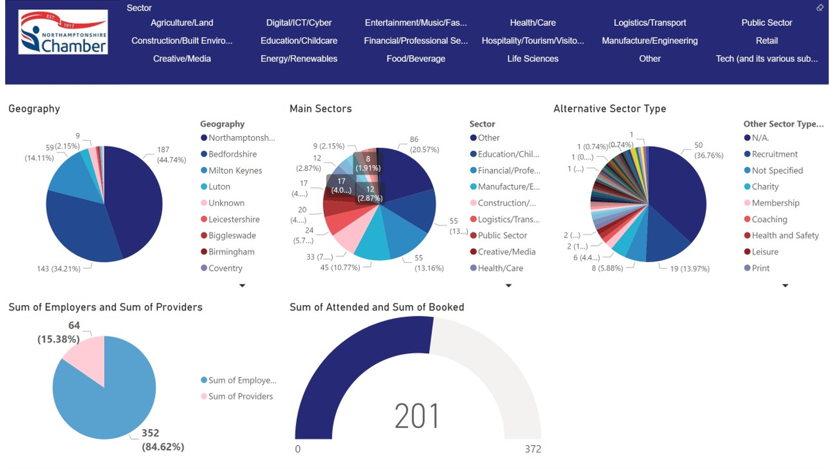

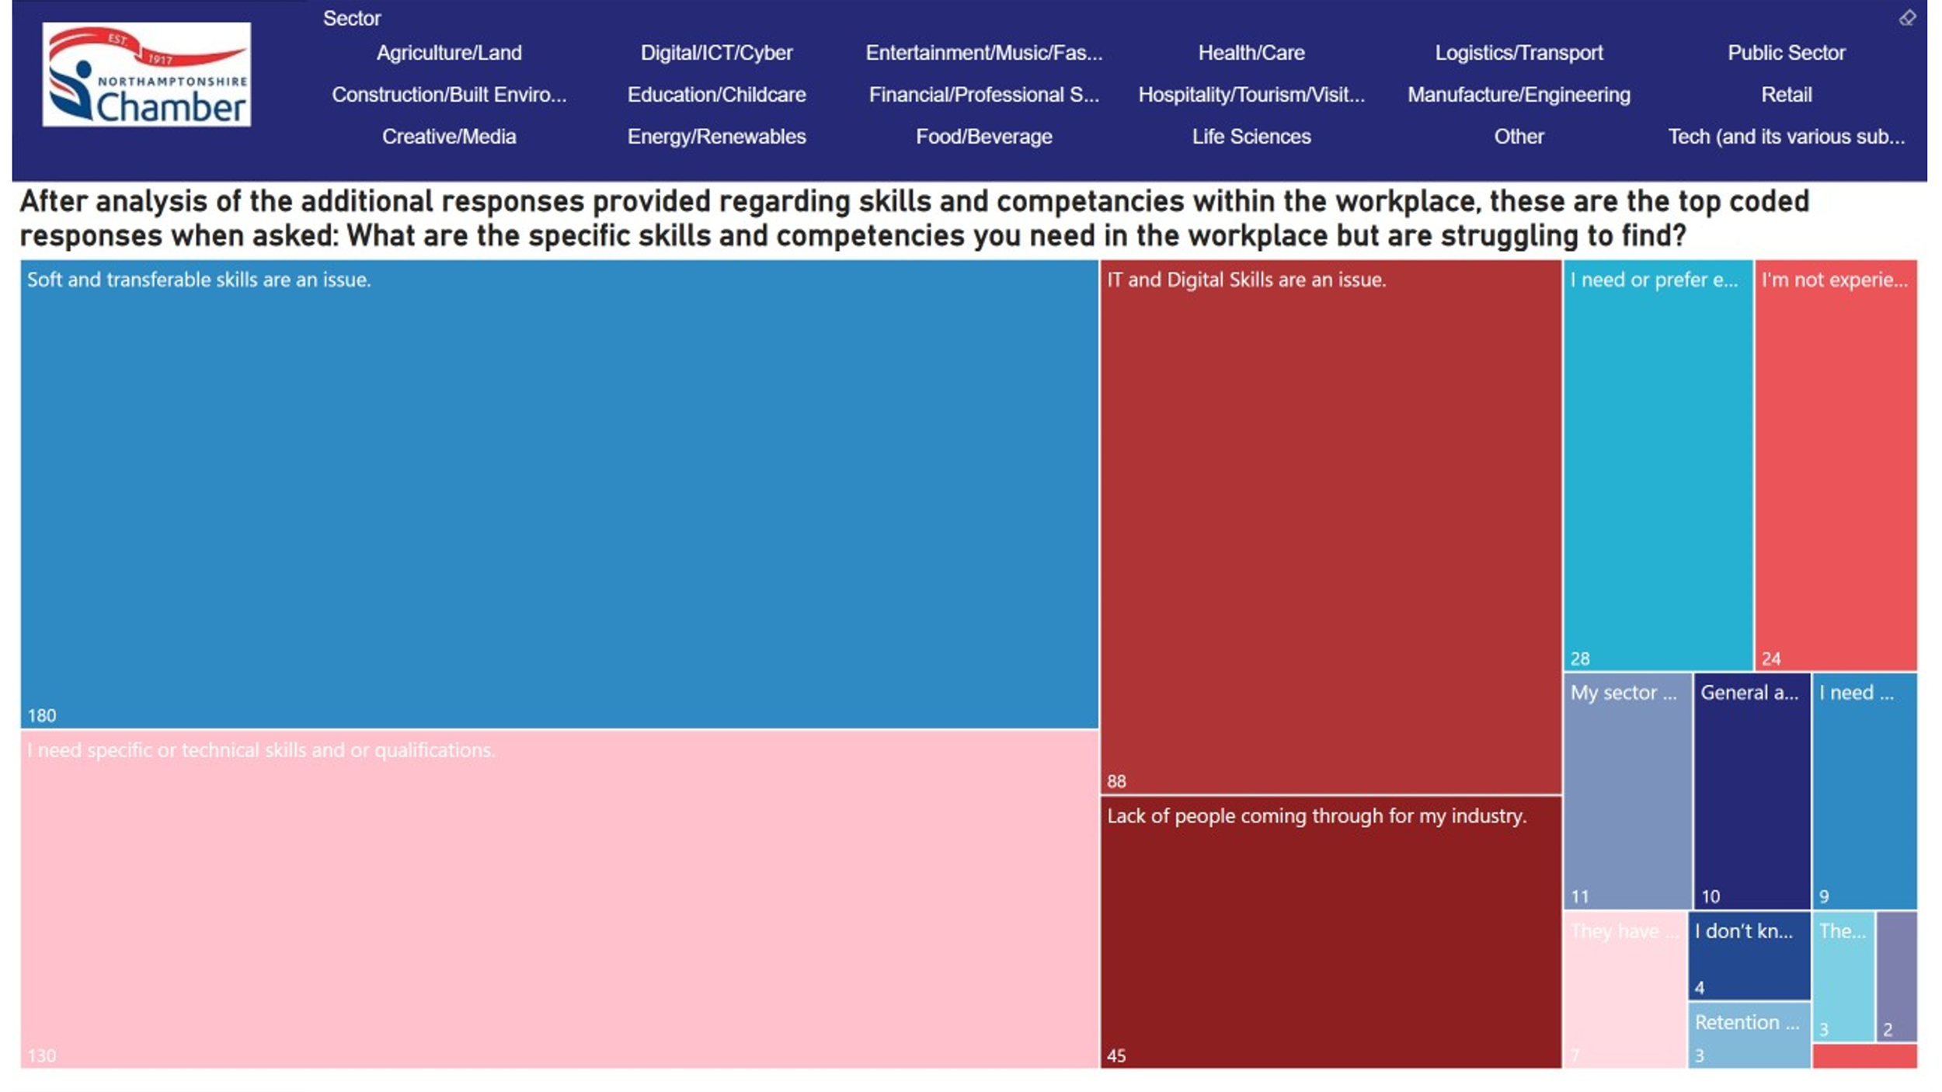

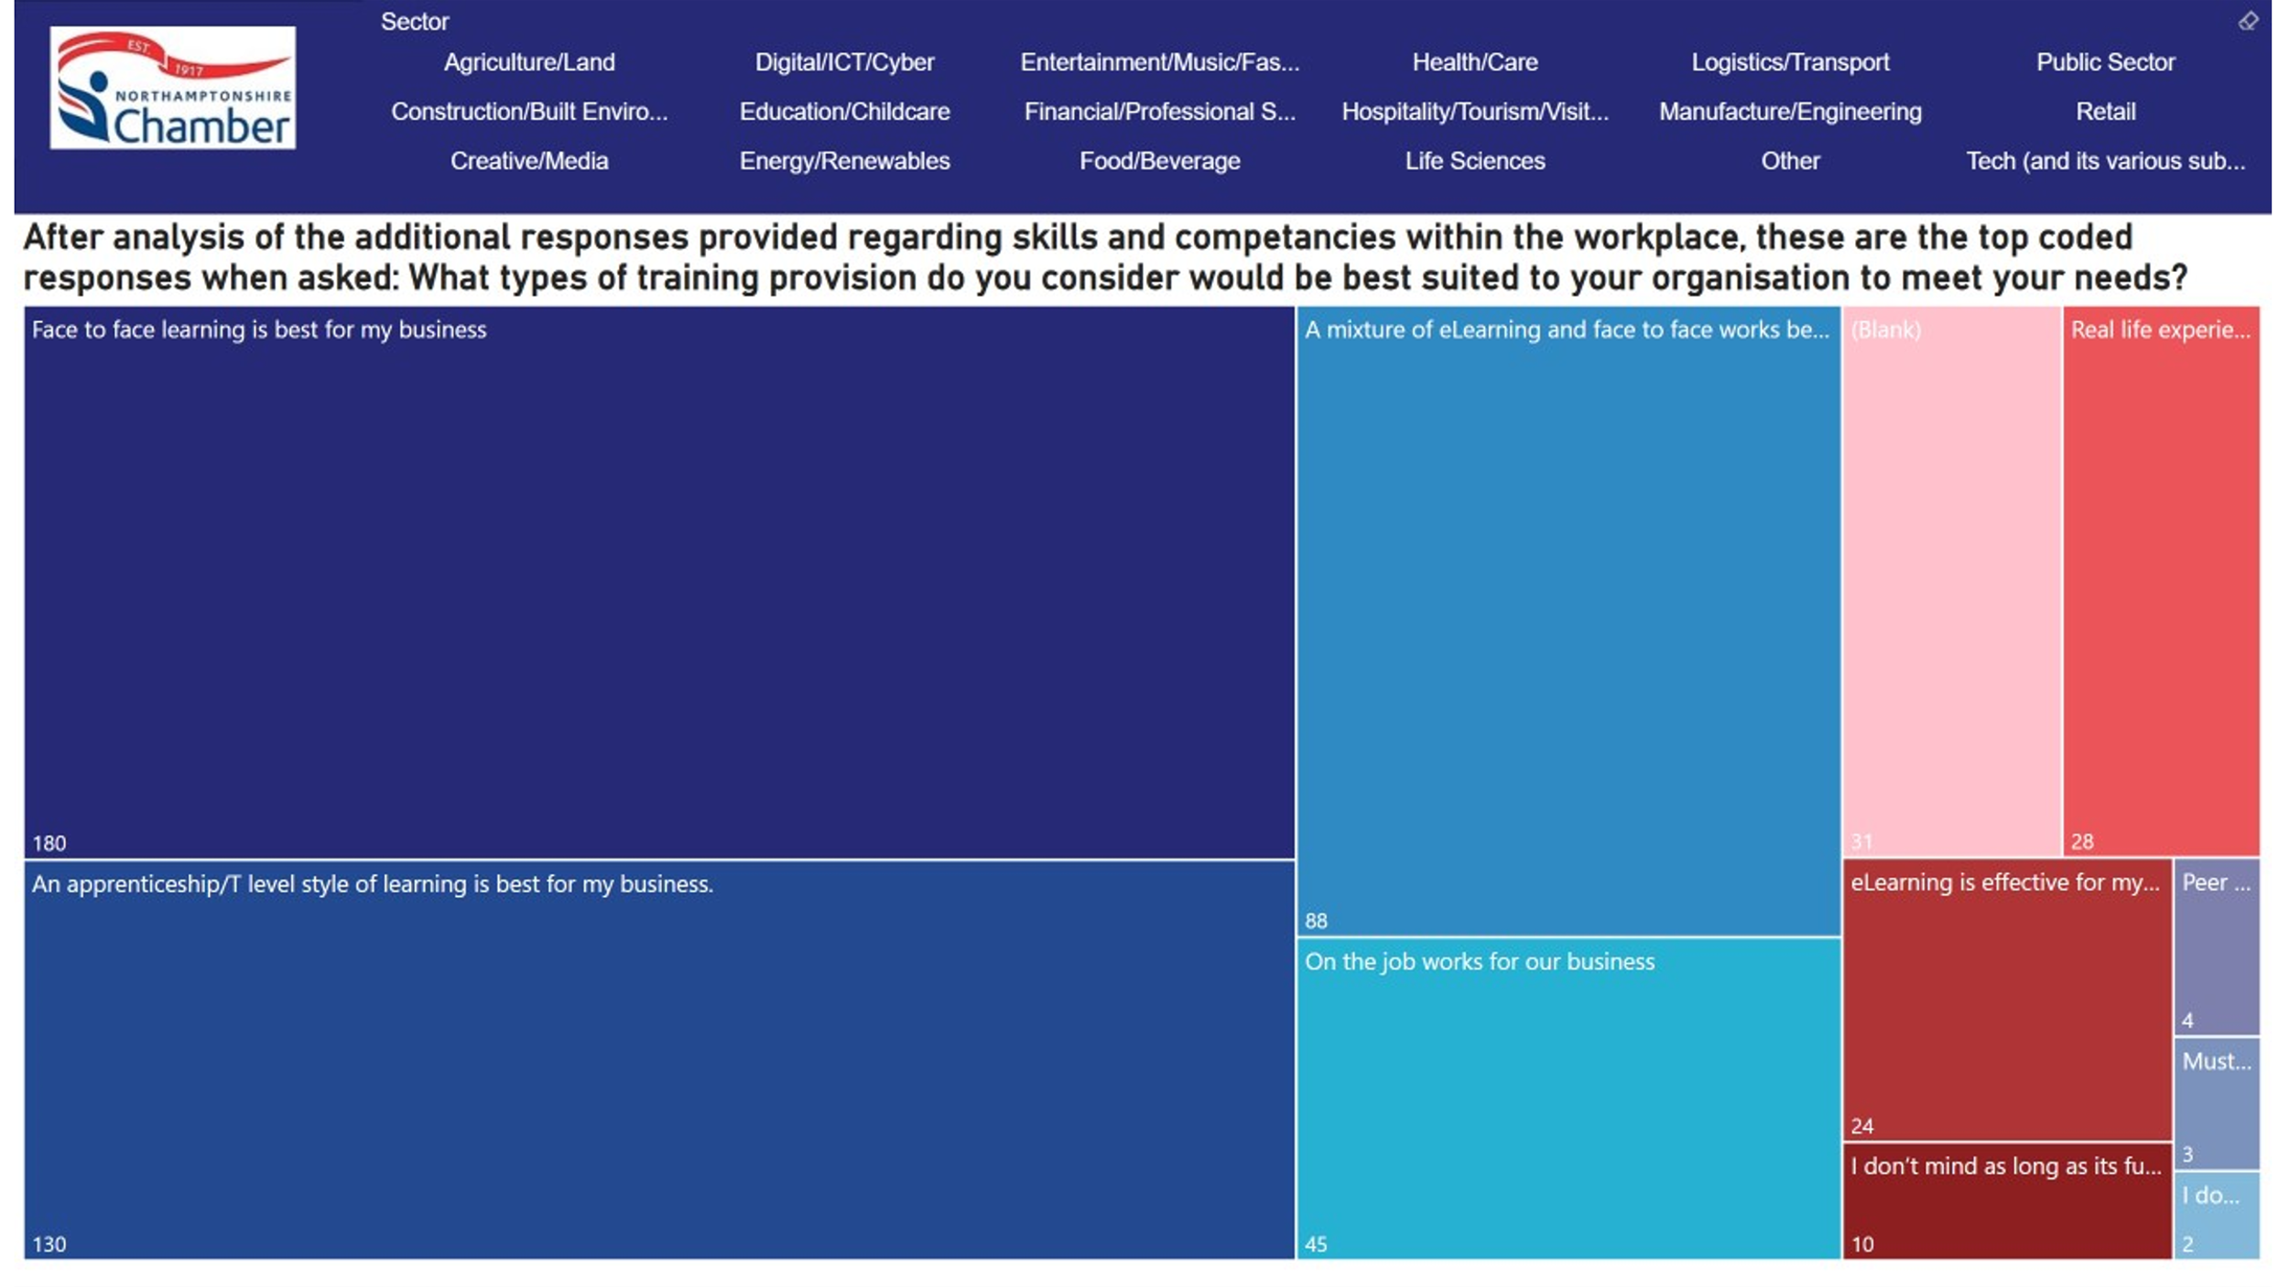

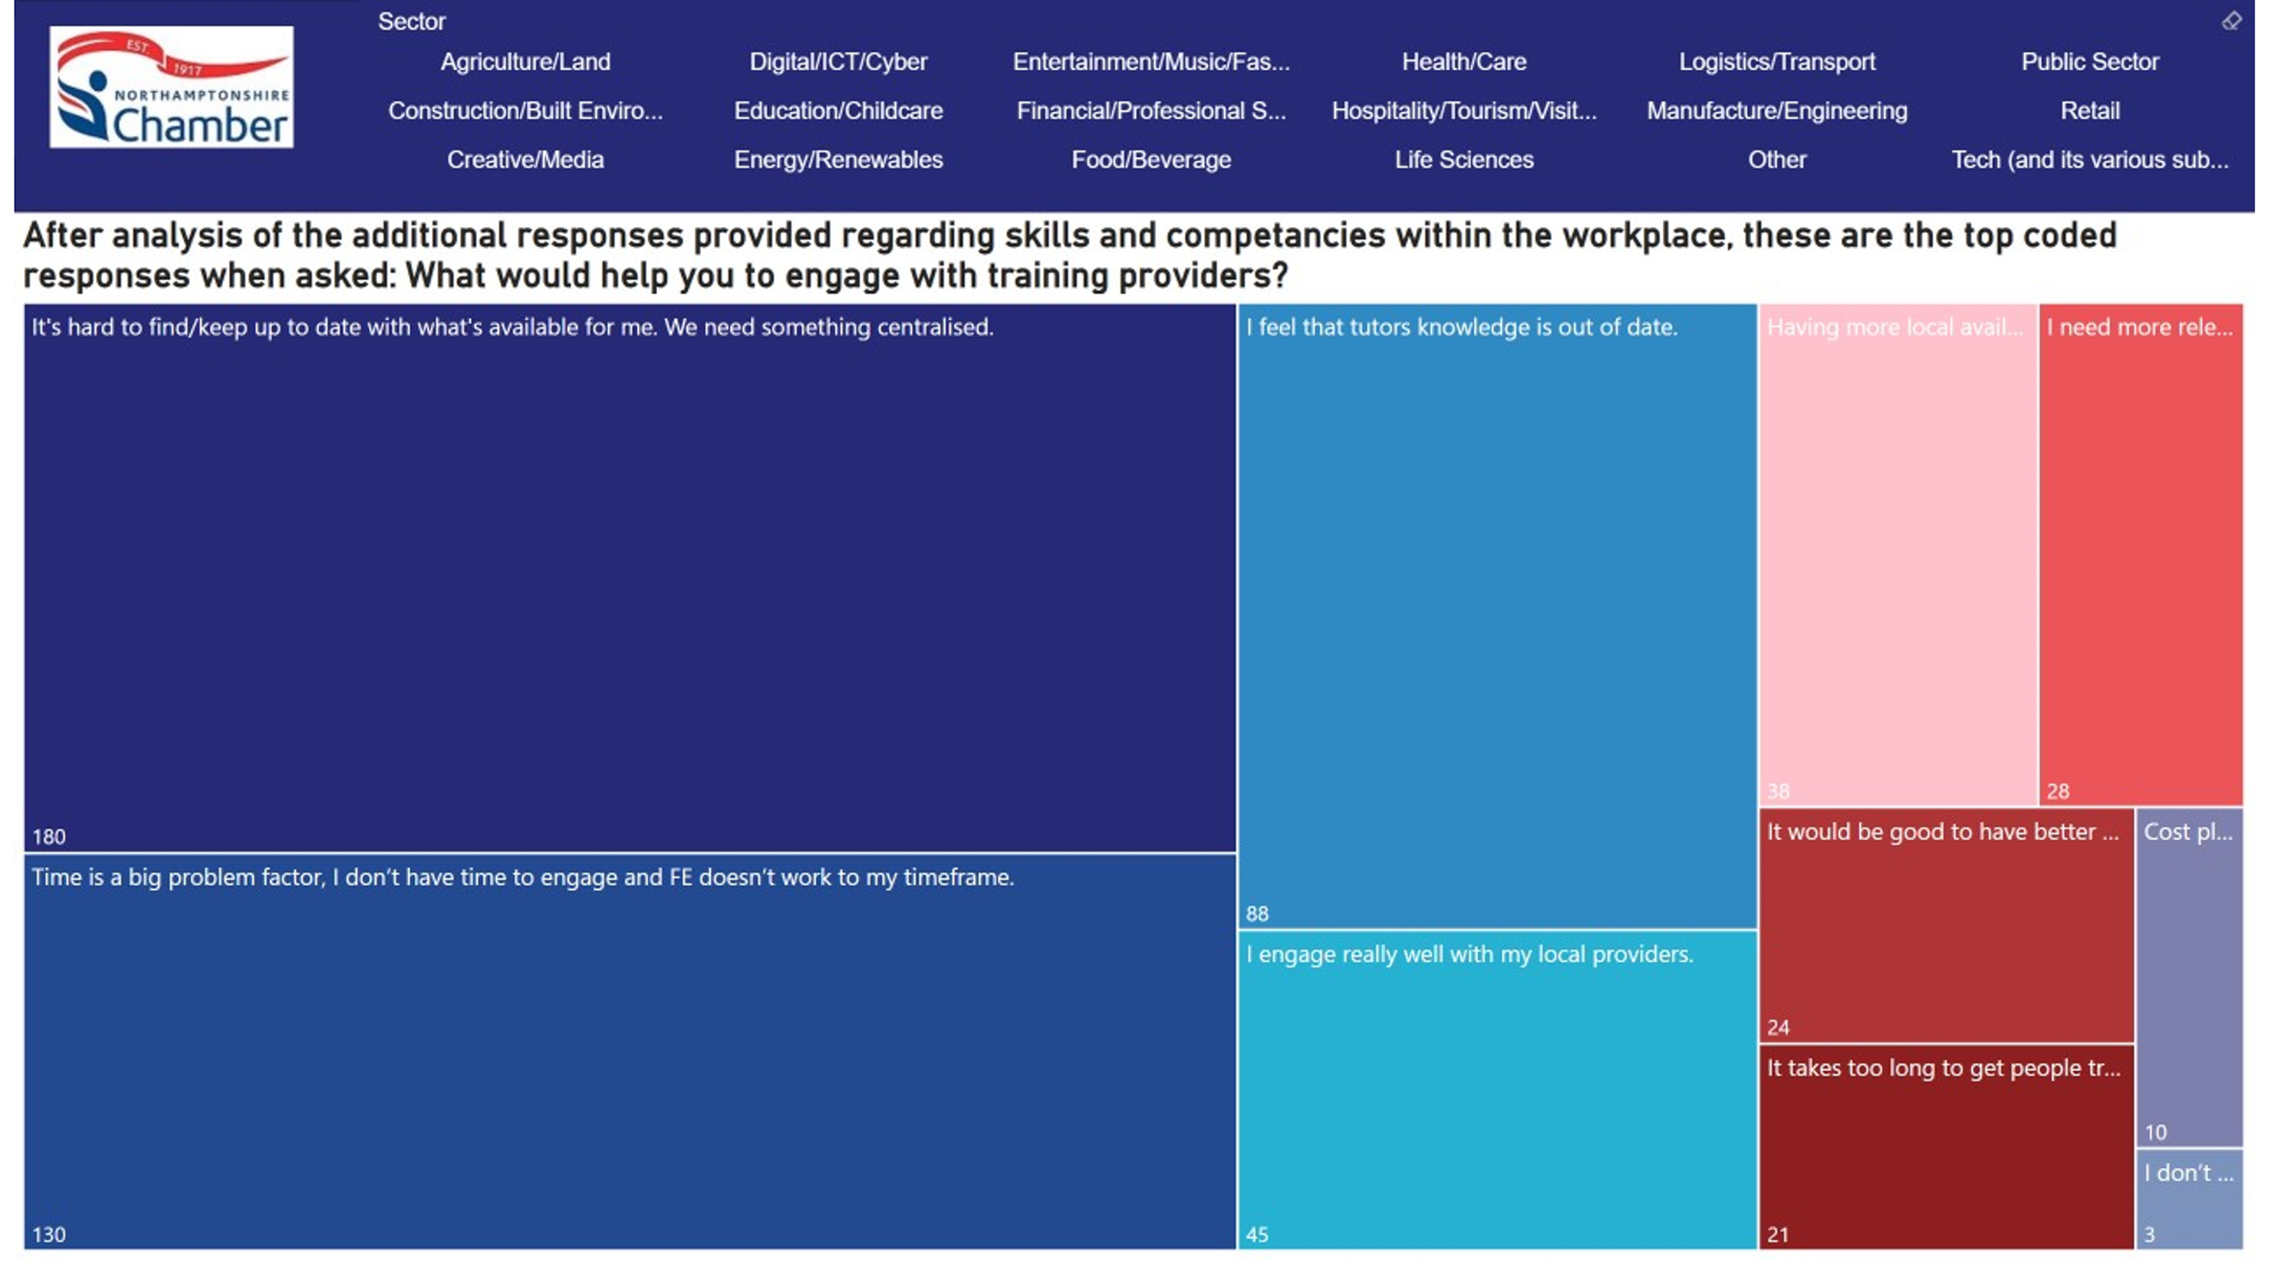

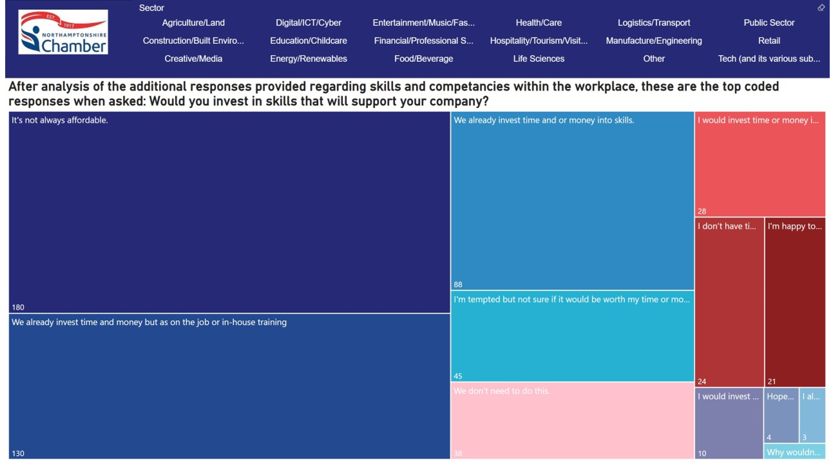

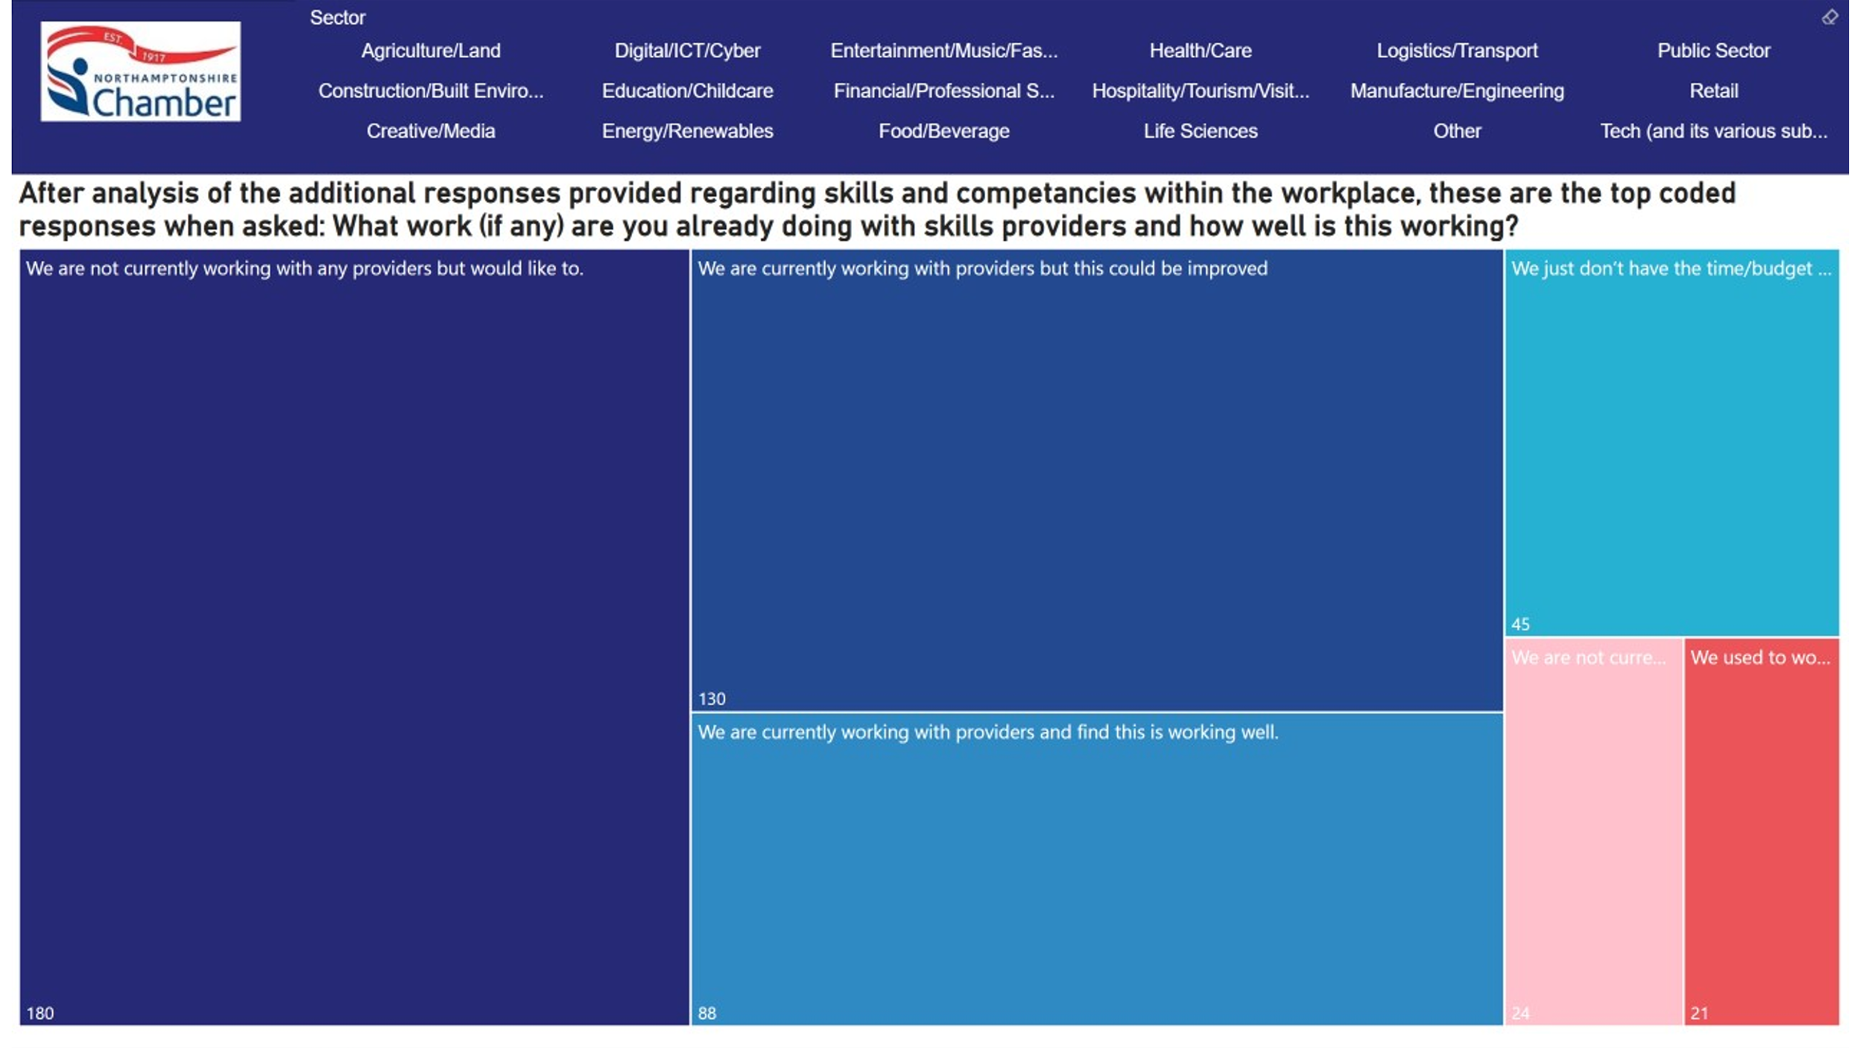

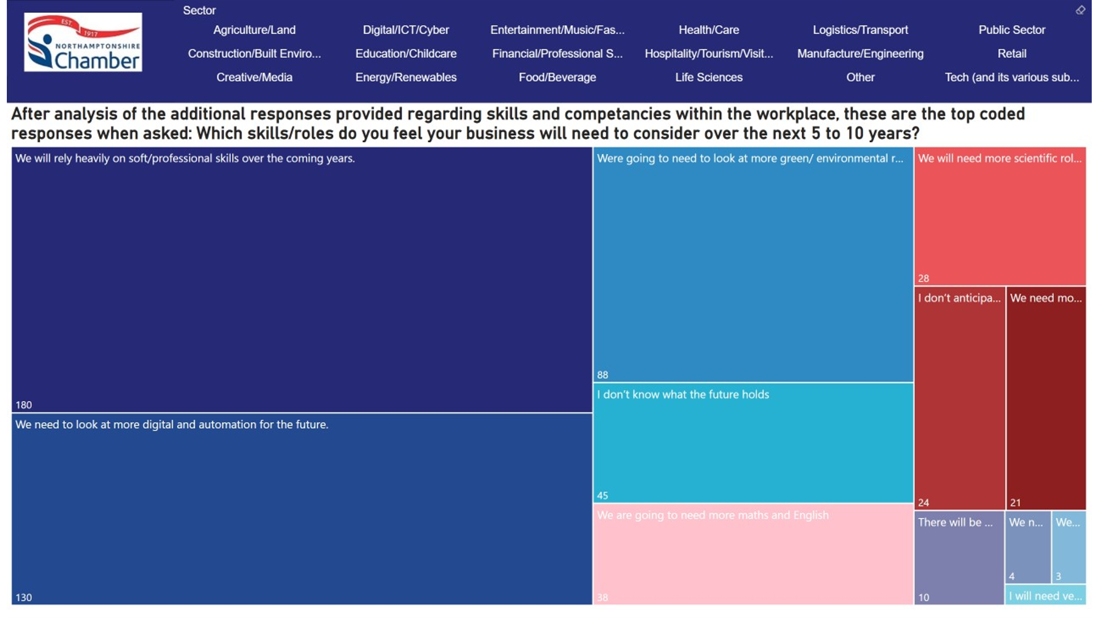

Annex D

LSIP Report Methodology
As per the Statutory Guidance for the Development of a Local Skills Improvement Plan (October 2022) we have put the LSIP report together following the required Stages:
- Stage A: Articulating employers’ skills needs – what are the skills employers need locally, but struggle to find?
- Stage B: Translating employer needs into changes in provision – how can those needs be met by providers in more responsive ways?
- Stage C: Addressing learner demand and employer engagement – what can local stakeholders and employers do to raise demand for and make better use of those skills?
The process was divided into three stages, following the project plan with milestones, timelines, and objectives.
- Part 1 scoped the project, identifying, aggregating and prioritising the skills and needs of employers to provide a broader perspective on local economic challenges and drivers.
- Part 2 included events and surveys and engagement with employers, providers, and job centres, allowing us to translate employer demands into provision and aligning, (where appropriate) with IfATE occupational routes and pathways. Also helping providers to understand how these can be taken forward by identifying existing provision of which employers are unaware.
- Part 3 included a roadmap of priorities designed in consultation with stakeholders, addressing learner demand and employer need

Our Local strategic context (Summary of the local strategic context and priorities relevant to LSIP) are embedded within the roadmap (Annex B) and this Annex is focused on providing further information on the methodologies/processes used to ensure:
- Evidence of skills need is robust, recognisable and meaningful to providers and other stakeholders.
- Evidence that the process for developing an LSIP has been followed in compliance with guidance

Methodology Objectives:
- Collaborate with local government bodies, employers, educational institutions, and 3rd party organisations to evidence skills needs in the region, considering factors such as industry demands, emerging sectors, and future workforce requirements.
- Engage and involve as many key stakeholders as is possible in the timeframe available, including local businesses, trade associations, schools, colleges, universities, and other 3rd parties in the process. Gather their insights, perspectives, and expertise to ensure the plan aligns with local needs.
- Develop a set of clear, simple, high-level outcomes reflecting the priority skills needs of employers to drive and focus meaningful dialogue with providers and others around the best ways of meeting them.

LSIP Activity Coordination:
- Northamptonshire Chamber of Commerce in conjunction with Milton Keynes and Bedfordshire Chamber are the Designated Lead for the development of the LSIP for the SEMLEP region.
- From September 2022 LSIP dedicated staff were assigned to the project, including a secondment from SEMLEP, senior leadership staff, Events and Marketing, Administration and Employer Relationship Developers from all 3 Chambers of Commerce within our region.
- Staff were recruited to manage survey results, contacting and liaising of staff across educational providers and businesses local to the area, co-ordinate mailing lists to deliver surveys and information about online and in-person business scoping events, marketing, data analysis and report writing.
- External consultants were commissioned for some employer engagement and qualitative data gathering via employer surveys, project management and collation of data research
- An LSIP Executive Group was formed (requests for members made via Linkedin, websites and emails) and includes regional membership from Local Authorities, FE Sector, HE Sector, Employers, FSB, Employer Trade Bodies, SEMLEP and the DWP
- A detailed project plan (overview of timelines shown on next page), staffing, project milestones etc was produced and reviewed by DfE. This was also reviewed by the LSIP Executive Group

Activities also included the following:
- Identifying stakeholders from various industries, educational institutions, government agencies, and job centres.
- Conducting initial meetings with stakeholders to gather insights on the challenges they are facing and to complete our Consultation Questions
- Throughout this process, regular meetings were held to ensure alignment, monitor progress, and address any issues that arose.
- Additionally, we focused on ensuring that the unique needs of small and medium enterprises, as well as larger corporations, were addressed. This comprehensive approach ensured that the project remained focused, well-coordinated, and successful in achieving its objectives.

Details of Project Activity:
Weekly from November 2022 to date (May 2023):
- Online LSIP updates and discussions with other ERB’s
- Internal discussions and updates on progress

To end of November 2022:
- External recruitment with staff to start December 2022
- Governance – Conflict of Interest (COI) and Register of Interest (ROI) documents
- LSIP delivery processes and policies
- Finalising membership of our Executive Group
- Communications - regular internal meetings for staff at all Chambers to ensure that everyone is “up to speed” with LSIP, its goals and the project plan.
- LSIP web page is already and LSIP articles have started on social media.
- Employer events being promoted in conjunction with FE Sector (MK and Northampton) and are arranging others (Luton) as well as discussing dates for sector specific events
- Stakeholder management at senior levels with a range of key organisations across the region

December 2022:
- External recruitment complete
- Governance – COI and ROI documents to sign and then publish.
- LSIP delivery Plan is kept updated and sent to stakeholders
- Communications - Chamber LSIP web page and LSIP articles on social media.
- Employer survey is now “live” and being promoted via stakeholders and social media.
- Employer events being promoted in conjunction with FE Sector
- Stakeholder management at senior levels with a range of key organisations across the region including CITB, all SEMLEP FE Principals, regional DWP and Local Authorities.

January/February 2023:
- 5 x employer/provider Face to face session(s) held and/or booked and promoted
- 1 x virtual event held (recruitment sector + DWP + restart)
- 11 x virtual (sector based) events booked online and being promoted via 3rd parties and website(s)
- Companies based in rural areas being called at a rate of 150 a week
- Meetings with FE/Local Authorities and 3rd party ERB’s / stakeholders continuing
- 30,000 business emails purchased and campaigns starting
- Governance – COI published on website
  - LSIP delivery Plan updated and sent to stakeholders
  - The Executive group met to discuss progress
- Communications
  - Chamber LSIP web page(s) live
  - Published LSIP articles in the Chamber magazine and also externally.
  - LSIP articles on social media.
  - Employer survey is being promoted via stakeholders and social media
- Stakeholder management – staff continue to engage at senior levels with a range of key organisations across the region
  - CITB, all SEMLEP FE Principals via the local college group, regional and local DWP and most Local Authorities.
  - Other ERB’s to promote LSIP and are finalising joint comms with FSB

March 2023:
- 5 x employer/provider Face to face session(s) held and 7 x virtual (sector based) events booked or held
- Companies based in rural areas (c.100 surveys completed)
- Meetings with FE/Local Authorities and 3rd party ERB’s / stakeholders continuing
- 30,000 businesses emailed with focused telemarketing follow up
- Governance
  - LSIP delivery Plan updated
  - The Executive group met in April to discuss progress and draft priorities
- Communications:
  - Chamber LSIP web page(s) receiving traffic
  - Several LSIP articles in the Chamber magazine and externally (CILT and NN business network)
  - 2-3 Chamber and external LSIP articles on social media per week (all logged)
  - Over 400 organisations have engaged with c.1200 comments
  - Draft priorities sent to FE Sector for review
  - Spoke at an event with the Minister for Small Business and promoted LSIP
  - Took space to promote LSIP at 3 exhibitions
- Stakeholder management –
  - SEMLEP FE Principals, regional and local DWP and most Local Authorities.
  - Continued engagement with other ERB’s locally to promote LSIP (especially NNBN) and FSB promoted LSIP in their newsletters

Employer facing events:
November 2022:
- 24th November – Business Leaders – Bedfordshire
- 24th November – Milton Keynes Business Exhibition
- 29th November – “Luton 2040” event
January/February 2023 – Initial information sessions and networking
- 31st January 2023 at Northampton College, Booth Lane – Networking and Information https://www.eventbrite.co.uk/e/477349002717
- 8th February 2023 – Business Exhibition, Northampton
- 28th February 2023 at Milton Keynes College, Chaffron Centre – Networking and Information https://www.eventbrite.co.uk/e/477355803057

March 2023 – Stakeholder engagement Sessions and networking – Online and In-Person
- 3rd March 2023 In-person event held at the Digital Aviation Research and Technology Centre (DARTeC) at the Cranfield Campus. There were nearly 100 attendees with 54 employer respondents to the Business Survey at this event, covering sectors in manufacturing and engineering, education and childcare, creative and media, tourism and hospitality, logistics and transport, and the public sector.
- 6th March – 13:00pm till 15:30pm – Education and Childcare
- 8th March - Northants Chamber Business Exhibition
- 20th March – 13:00pm till 15:30pm – Financial and Professional
- 20th March – LSIP & Tresham College Event
- 21st March – 09:00am till 11:30am - Retail
- 23rd March – LSIP and Central Bedfordshire College Event
- 27th March – 13:00pm till 15:30pm – Logistics and Transport
- 27th March at 09:00 - Recruitment Agencies
- 30th March – 13:00pm till 15:30pm – Public Sector
- 30th March at 09:00 - IT and Digital
- 31st March 2023 at Kettering Park Hotel & Spa – Networking and Information

April and May 2023 – Feedback and final engagement sessions
- 18th April - Stakeholder roadmap session – Bedfordshire
- 26th April – Stakeholder roadmap session – Bedfordshire
- 10th May – Stakeholder feedback session - Northampton
- 18th May – Careers Enterprise Company (Apprenticeships and Technical Education) – Milton Keynes College

Other stakeholder activities throughout the project:
- DfE LSIP events (online and face to face)
- Discussions, presentations and meetings with Careers Enterprise, Skills Hub, IfATE, other Chambers of Commerce (London First, Buckingham Business, Coventry & Warwickshire), SEMLEP SAP and Government Minister for Small Business
- One to one meetings with DWP
- Attendance at 3rd party employer events (City MK, All things Business, NNBN, FSB)
- Executive Group meetings

Employer and Stakeholder Consultations:
To obtain responses from local representatives from different industries, including small, medium, and large corporations, as well as government and educational institutions, we included several steps of engagement:

- We procured a communications/telemarketing company to undertake employer surveys targeting rural areas and key sector organisations.
- Social Media Marketing included e-shots and newsletters, Twitter, Facebook and LinkedIn, and through Eventbrite.
- Website links and Linktr.ee links were also included to ensure information and surveys were easily accessed and could be advertised at each event as well as online events. QR codes facilitated the distribution of the survey link.
- Bedfordshire Chamber of Commerce collaborated with Bedford, Central Bedfordshire and Luton Councils to align understanding of employer skills requirements in the region with the Local Skills Improvement Plan (LSIP) for the South East Midlands.
- Consultations included online surveys administered by the Chamber(s) and a number of events where employer group discussions were facilitated. (We also reviewed regional employer feedback in the recent SDF project and the SEMLEP local business survey). It was noted that, despite multiple engagement channels used, attendance rates at events were only 55% of those booked and online survey response rates achieved were not as high as wished. Feedback from employers being :
  - There is a real lack of enthusiasm to complete surveys at the moment
  - Time constraints
  - Higher priorities

Employer and Stakeholder engagement:
- Employer Engagement included Employer Representative Bodies such as the Federation of Small Businesses and NNBN, attendance at employer facing exhibitions and events with 3rd parties, interaction with Sector Trade Bodies, Press Articles in a range of business publications and media alerts to Chamber members etc. It was noted that more engagement will be required with Sector Leads and Independent Training Providers as we progress with LSIP (and LSIF)
- Provider Engagement included Further Education (FE) Sector in our region, Institute of Technology, Local Authorities, Skills Hubs, Independent Training Providers and Higher Education Providers
- Wider Stakeholder Engagement included Dept of Work and Pensions (Job Centre Plus), European Social Fund and unemployment programme providers, Youth employment, FE learners and Careers Enterprise Network
Overview of event management and engagement:
Events were managed as follows:
- Attendance data gathered. Presentation to set the scene, providing insight on the background to the Local Skills Improvement Plan and purpose of the event. Key indicators relating to demography, labour markets, employment and skills were presented to stimulate debate.
- Break out groups facilitated to get employer views on skills demand, skills supply, sector specific requirements and target groups using interactive Mentimeter QR code technology and annotated post-it notes in response to key questions posed. Attendees circulated around each group in turn.

Rooms used a “Round Table” approach with a table host, who assisted attendees with downloading the survey software (Mentimeter). Paper copies were also provided to ensure accessibility for all attendees. Banners and Leaflets were also advertised with the QR code linking to further events and to the full survey in case attendees wanted to complete the survey at a later date.
The table host assisted with queries as needed to ensure attendees understood the survey questions and were able to provide accurate information. They also facilitated additional questions and noted responses to add to qualitative data.
Key speakers introduced the LSIP and the objectives for the meeting. Current employment data were presented in a way that each attendee could understand how participation in the LSIP event might be beneficial to their industry and their company.
At the events, respondents had options to answer some key questions: using a QR code to an online questionnaire and/or via post-it notes and discussion at the roundtable.
What are the specific skills and competencies you need in the workplace but are struggling to find?
What types of training provision do you consider would be best suited to your organisation to meet your needs? (Please tick as many answers as relevant)
What would help you to engage with training providers? (Please tick as many answers as relevant)
Which skills/roles do you feel your business will need to consider over the next 5 to
10 years? (Please tick as many answers as relevant)
Would you invest in skills that will support your company? (Please tick as many
answers as relevant)
Does your organisation require staff to have any of the following (Please select as
many as relevant)
What work (if any) are you already doing with skills providers and how well is this
Working [invited to write as much as needed]
In an ideal world what would work within your sector? [invited to write as much as needed]
Employer Survey Data Collection:
- We designed and distributed surveys and questionnaires to stakeholders, gathering quantitative and qualitative data on job vacancies, skills required, and the difficulty in recruiting talent. This formed objectives that would let us compare this data with those from national and local employment and education statistics.
- Data included demographic information, the industry they represent, and several questions on their experiences.
- Responses included closed questions with options where respondents could select as many choices as was true to them in their company.
- There were also open form responses where respondents could write in paragraph form about their individual perspectives. We also offered “Other” options for perspectives which did not fit into the closed options given. This allowed us to examine the opinions and perspectives of employers in their own way of phrasing it. This is important in scoping exercises because some employers likely could have experiences that fall outside of what the team had expected, particularly if they represent a smaller industry or type of business that is typically not surveyed.
- The questions included queries specific to the LSIP objectives to understand the current struggles in industry. We also worded questions to probe for objections and opportunities for creating headway for LSIP exercises going forward to 2024 and beyond, such that employers will likely need to forge relationships with educational providers.

Note: Each had open boxes to write further comments on their answer.

Data Analysis:
- We worked with the LEP to update data analysis and labour market intelligence, including trend analysis and identification of gaps and challenges. We analysed the data to identify patterns, trends, and industry-specific recruitment challenges.
- These analyses allowed us to assess existing skills supply, courses, innovations, partnerships, and cross-cutting themes which were then illustrated using Power BI.
- The focus group discussions with stakeholders provided quantitative and qualitative insights and these were illustrated in word clouds based on the coding that we assigned to the written open responses. Tallies of responses were also shown by industry and business type. Again, these were created using Power BI.
- We received over 2,100 pieces of feedback from c.420 organisations in our direct consultation exercise. We also reviewed employer feedback and skills observations in both the SDF report and the event held at DARTeC to verify and validate.
- We also examined external data sources across government portals, including education (Department for Education) https://department-for-education.shinyapps.io/local-skills-dashboard/ and national statistics, such as Business Register and Employment Survey and Annual Population Survey, Workplace Analysis, ONS, Lightcast and SEMLEP Business Surveys.
- Skills gaps data were also explored through national databases on apprenticeship enrolment and completion. Additionally, local colleges provided data on courses and apprenticeships enrolment and completion: Milton Keynes College, Barnfield College, Central Bedfordshire College, and Luton College.

Priority Roadmap Creation:

- Based on the data analysis, we developed a working LSIP (draft) priority list that we shared among the LSIP Executive Group and with stakeholders to assess the potential next steps, feasibility and to seek additional perspectives. This resulted in a variety of useful comments and observations which were incorporated into the LSIP.
- We held workshops and co-created with providers and stakeholders a set of clear, specific, and actionable priorities for change to improve the labour market relevance of provision and deliver better outcomes for learners, and embed greater employer engagement in local skills systems to bring the demand and supply sides more closely together and enable a more coherent “whole system” approach to skills planning.
- Based on discussions and further engagement, we refined the strategic priorities based on feedback and developed an implementation roadmap.
- Throughout the project we shared draft reports, including the findings, recommendations, and implementation roadmap with Further Education, Chamber Directors and stakeholders.
- We have also organised an LSIP Stakeholder workshop (June 2023) to present on the findings and best practices for addressing and supporting the delivery of the identified challenges. A draft flowchart showing an outline for discussion is attached in Annex B

Ongoing and next steps:
- To be detailed as per existing Project plan and DfE Part 2 Guidelines. Specifically ERB requirements and LSIF.

Annex E
Reports:

Sectors
Digital Sector 2022
Creative Sector 2022
Construction Sector 2022
Retail Sales Sector 2022
Public Sector 2022
Manufacturing Sector 2022
Logistics Sector 2022
Hospitality Sector 2022
Health Sector 2022
Green Economy Sector 2022
Financial Sector 2022
Education Sector 2022
Business Admin Sector 2022

Job Postings Learner Pipeline Occupation Skills Future Projections

Focus Rationale LEP Business Survey Employment Nov 2022 Gov skills 2022

SDF Evaluation report
Employer event (Bedfordshire)
ATE workshop

Annex F

External Referencing
- https://feweek.co.uk/norfolk-shows-the-solutions-to-national-apprenticeship-challenges-are-local/
- https://d68b3152cf5d08c2f050-97c828cc9502c69ac5af7576c62d48d6.ssl.cf3.rackcdn.com/documents/user-upload/kingston-university-3bfff097ef8-kingston-university-d2606ad3a3d.pdf
- https://www.gov.uk/government/groups/unit-for-future-skills
- https://feweek.co.uk/digital-skills-gaps-and-shortages-mean-its-time-to-scale-up-to-level-up/
- https://www.edge.co.uk/documents/330/DD0878_-_Skills_Shortages_Bulletin_11_DIGITAL.pdf
- https://www.citb.co.uk/about-citb/what-we-do/plans-and-performance/net-zero-action-plan/
- https://women-into-construction.org/
- https://www.pwc.co.uk/who-we-are/our-purpose/building-trust-in-the-climate-transition/supporting-a-fair-transition/green-jobs-barometer.html
- https://www.instituteforapprenticeships.org/about/newshub/news-events/tackling-inequalities-and-lack-of-diversity-across-apprenticeships-and-skills-training/
- Occupational Maps / Institute for Apprenticeships and Technical Education
- https://department-for-education.shinyapps.io/local-skills-dashboard/
- https://assets.publishing.service.gov.uk/government/uploads/system/uploads/attachment_data/file/957856/Skills_for_jobs_lifelong_learning_for_opportunity_and_growth__web_version_.pdf
- https://educationlandscape.org.uk/
- https://www3.weforum.org/docs/WEF_Future_of_Jobs_2023.pdf
- https://ocr.org.uk/Images/676490-post-16-level-3-qualification-reform-quick-reference-guide.pdf
- https://feweek.co.uk/seismic-changes-to-post-16-qualifications-landscape/
- https://occupational-maps.instituteforapprenticeships.org/
- https://www.citb.co.uk/about-citb/construction-industry-research-reports/search-our-construction-industry-research-reports/building-skills-for-net-zero/
- https://www.citb.co.uk/about-citb/construction-industry-research-reports/search-our-construction-industry-research-reports/net-zero-and-construction-perspective-and-pathways/
- https://www.local.gov.uk/our-support/financial-resilience-and-economic-recovery/mapping-national-employment-and-skills

ANNEX G
Top 60 Occupations (recruitment shortages and future demand)
- Account Manager / Representative
- Accountant
- Automotive Service Technician / Mechanic
- Bookkeeper / Accounting Clerk
- Business / Management Analyst
- Buyer / Purchasing Agent
- Care assistant
- Caregiver / Personal Care Aide
- Chef
- Civil Engineer
- Computer Support Specialist
- Computer Systems Engineer / Architect
- Construction Helper / Worker
- Credit Analyst / Authoriser
- Customer Service Representative
- Data / Data Mining Analyst
- Delivery Driver
- Electrical Engineer
- Electrician
- Financial Manager
- Food Service Team Member
- General cleaner
- Healthcare Manager
- HGV / LGV Class 1 Driver
- HGV / LGV Class 2 Driver
- Human Resources / Labour Relations Specialist
- IT Project Manager
- Kitchen Staff
- Labourer / Material Handler
- Lawyer
- Maintenance Technician
- Manufacturing Machine Operator
- Marketing Manager
- Mechanical Engineer
- Nursery nurses, assistants and playworkers
- Nursing Assistant / Healthcare Assistant
- Office / Administrative Assistant
- Operations Manager
- Physician
- Primary School Teacher
- Production Worker
- Project Manager
- Receptionist
- Recruiter
- Registered General Nurse (RGN)
- Retail Sales Associate
- Retail Store Manager / Supervisor
- Sales Assistant
- Sales Manager
- Sales Representative
- Scheduler / Operations Coordinator
- Security Officer
- Senior Administrator
- Software Developer / Engineer
- Teaching Assistant
- Tutor
- University Lecturer
- Utilities Technician
- Warehouse / Inventory Associate
- Welder / Solderer

Annex H
Proposed Provision
Apprenticeships | Level
Urban driver | Level 2
Large goods vehicle lgv driver c + e | Level 2
Supply chain warehouse operative | Level 2
Express delivery sortation hub operative | Level 2
Express delivery operative | Level 2
Food and drink process operator | Level 2
Lean manufacturing operative | Level 2
Professional security operative | Level 2
Commercial thermal insulation operative | Level 2
Construction assembly and installation operative | Level 2
Motor Vehicle Service and Maintenance Technician (Light Vehicle) | Level 3
Digital marketer | Level 3
Marketing assistant | Level 3
Machining technician | Level 3
Food and drink technical operator | Level 3
Security first line manager | Level 3
Industrial thermal insulation technician | Level 3
Low carbon heating technician | Level 3
Refrigeration, air conditioning and heat pump engineering technician | Level 3
Sales executive | Level 4
Market research executive | Level 4
Marketing executive | Level 4
Public relations and communications assistant | Level 4
Associate project manager | Level 4
Logistics operations warehousing manager | Level 4
Business to business sales professional | Level 6
Digital marketer | Level 6
Marketing manager | Level 6
FE Full-Time | Level
Maintenance, installation and repair for engineering and manufacturing - Light and Electric Vehicles | T Level
Food and drink technical operator | T Level
Installation and maintenance electrician | T Level
Refrigeration, air conditioning and heat pump engineering technician | T Level
Plumbing and domestic heating technician - Environmental Technologies | T Level
Domestic, Commercial & Industrial Electrical Vehicle Charging Equipment Installation City & Guilds | Level 3
Installation & Maintenance of Small Scale Solar Photovoltaic Systems City & Guilds 2399-12 | Level 3
Domestic Electric Vehicle Charging Equipment Installation | Level 3
Converter Provision - Short courses/training to upskill/reskill
Account Manager/Representative
Marketing Manager
Project Manager
Scheduler/Operations Coordinator
Security Officer - limited specialist provision in place.
Utilities Technicians (including Electricians, Plumbing, Heating, Green Energy and Retrofit)

